Meltwater to Megawatts
Chapter 1 draft — built 2026-09-29 16:45 (commit 92145de)
Kai Myers
[co-authors to be settled with the adviser]

Abstract
Dixon Glacier (38 km², Kenai Peninsula, Alaska) is the proposed source of a diversion to the Bradley Lake hydroelectric project, whose viability depends on the glacier’s future runoff. We calibrated a distributed radiation-enhanced temperature-index model in a Bayesian framework to three years of stake mass balances, the 2010–2020 geodetic mass balance and branch-resolved snowlines, and tested it against withheld records. We projected glacier geometry and runoff to 2100 under three emissions scenarios in 5,600 runs that bracket the climate model, the ice thickness, the model parameters and the transmission of valley warming to the glacier surface. Modelled mass balance averaged −0.87 m w.e. a⁻¹ over 2011–2025. Pooled over the ensemble, runoff peaks in 2041, 2058 and 2063 under SSP1-2.6, SSP2-4.5 and SSP5-8.5, within 5 years of a global projection that uses no ground observation. The result depends on transmission. With full transmission runoff rises to 1.19–1.37 times its 2011–2024 mean and peaks at mid-century; with damped transmission it stays within 15% of that mean. In neither case does ensemble-mean runoff in 2081–2100 fall below that of 2011–2024, but it shifts from summer melt towards autumn and winter rain. Additional on-glacier temperature records would narrow the largest uncertainty in the timing.

1 Introduction
Runoff from a shrinking glacier first increases, as a growing area of exposed ice melts faster than the loss of glacier area can offset, and then declines once the glacier has become too small to sustain it. The year of maximum annual glacier runoff is termed peak water (Huss and Hock, 2018). The high latitudes are warming fastest: the Arctic warmed nearly four times faster than the global mean over 1979–2021 (Rantanen and others, 2022). Alaska’s glaciers accounted for 25% of global glacier mass loss over 2000–2019 (Hugonnet and others, 2021), lose about 75 Gt a⁻¹ (Larsen and others, 2015), and are projected to be the largest regional contributor to sea-level rise through 2100 (Rounce and others, 2023). Peak water occurs later in basins with larger glaciers and higher ice cover (Huss and Hock, 2018), and Alaska is therefore expected to reach it later than most glacierized regions (Geck and others, 2021).
On the Kenai Peninsula, glacier area decreased by about 12% between 1986 and 2016 (Yang and others, 2020). Dixon Glacier, an outlet of the Harding Icefield, covered 38 km² in 2025. The Alaska Energy Authority is pursuing the Dixon Diversion, a dam near the glacier terminus and a tunnel of about 8 km that would route Dixon’s runoff into Bradley Lake, the state’s largest hydroelectric project, and increase its annual generation by about 50%. The viability of the project depends on whether Dixon’s runoff will remain sufficient over its operating life.
A projection for Dixon exists. The global glacier model of Rounce and others (2023) places its peak water at 2044, 2058 and 2058 under SSP1-2.6, SSP2-4.5 and SSP5-8.5 (computed here from the published runoff series; Section 4.6). That model runs at a monthly time step on elevation bands, is forced by reanalysis, and is calibrated to geodetic mass balance alone with a single parameter set per glacier (Rounce, Hock, and others, 2020); it uses no observation from Dixon itself. Its projections are presented as spatially resolved at the glacier scale (Rounce and others, 2023), and at that scale the authors note that uncertainty from model parameters can be significant (Rounce, Hock, and others, 2020). Geck and others (2021) calibrated a distributed temperature-index model of Eklutna Glacier jointly to in-situ point balances, geodetic mass balance and satellite-derived snowlines, reconstructed 35 years of mass balance and discharge, found that peak water had not been reached, and proposed forecasting it with the same model. No projection constrained by local observations exists for Dixon.
Here we project Dixon Glacier’s mass balance and runoff to 2100 with a model constrained by observations from the glacier. Surface mass balance is computed daily on a 100 m grid with a radiation-enhanced temperature-index model (Hock, 1999), forced by a nearby long-term station through a transfer function fitted to two summers of on-glacier measurements. Glacier geometry evolves by the Δh parameterization of Huss and others (2010), tested against the glacier’s outlines from 2000 to 2025. Parameters are calibrated in a Bayesian framework to three years of stake mass balance, geodetic mass balance for 2010–2020 (Hugonnet and others, 2021) and branch-resolved snowlines, and the calibrated model is evaluated against records withheld from calibration: the 2000–2010 geodetic mass balance, Sentinel-1 melt-extent elevations (Wells and others, 2026) and the mass-balance record of the USGS benchmark Wolverine Glacier (O’Neel and others, 2019). Projections use bias-corrected CMIP6 forcing under SSP1-2.6, SSP2-4.5 and SSP5-8.5, two ice-thickness products (Farinotti and others, 2019; Maffezzoli and others, 2025), 100 posterior parameter sets, and two assumptions about how much of the valley’s slow warming reaches the glacier. Our objectives are (1) to determine whether Dixon Glacier has already reached peak water and, if not, when it will; (2) to characterize the magnitude and seasonality of runoff after the peak; and (3) to compare a locally constrained projection with the global model’s.

2 Study site
[KAI: the study-site paragraph. It carries the first citation of the map (Fig. 1).]
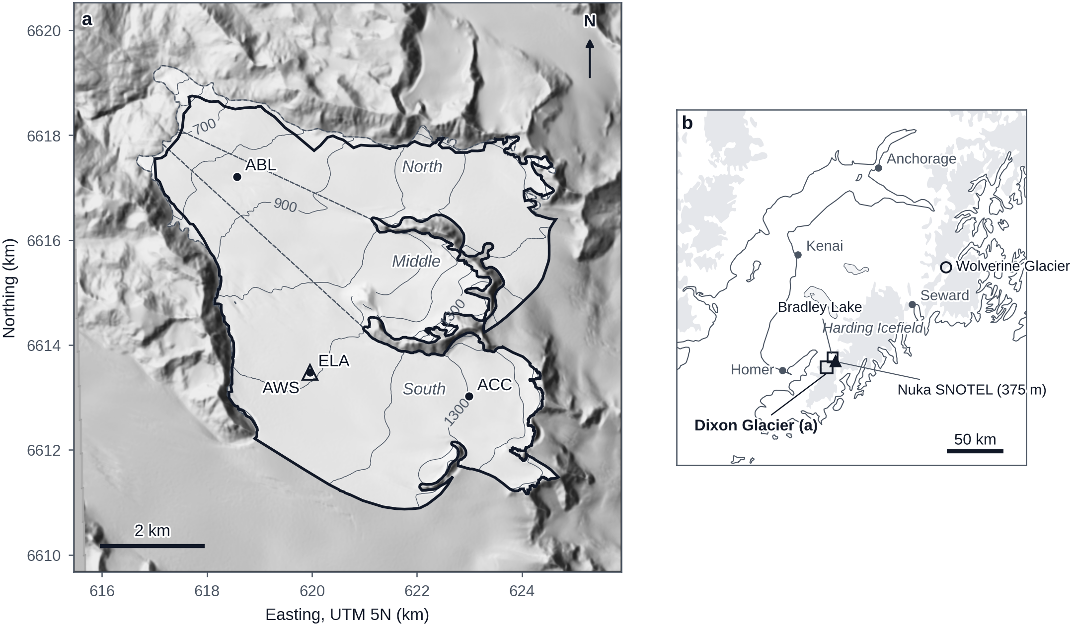
Fig. 1. Dixon Glacier and its setting. (a) The glacier on a shaded-relief image of the 2010 IfSAR digital elevation model, in UTM zone 5N coordinates. The light fill is the 2000 outline, which defines the model domain (40.11 km²), and the bold line is the 2025 outline (38.34 km²). Thin lines are 100 m surface contours and dashed lines divide the north, middle and south branches. Dots mark the mass-balance sites ABL, ELA and ACC at 804, 1078 and 1293 m a.s.l., and the open triangle marks the automatic weather station at the ELA site. (b) The Kenai Peninsula, with glacierized areas in grey. The rectangle is the area of panel a. The filled triangle is the Nuka SNOTEL station (375 m a.s.l., 9 km from the glacier centroid), which supplies the long-term forcing. The open square is Bradley Lake, the reservoir that the proposed diversion would feed. The open circle is Wolverine Glacier, the USGS benchmark glacier used for validation, 137 km to the northeast. Small dots are towns. Outlines were digitized from Landsat scenes, site positions are GNSS surveys of spring 2024, and the coastline, lakes and glacierized areas are from Natural Earth. All three mass-balance sites lie on the south branch.

3 Data
The model is forced with daily air temperature and precipitation from the nearest long-term station, transferred to the glacier through a function fitted to two summers of on-glacier measurements (Section 4.2), and driven to 2100 with bias-corrected climate-model output (Section 4.6). Calibration uses in situ point mass balances, a geodetic mass balance and satellite-derived snowlines. Validation uses records withheld from calibration (Section 3.6). Table 1 lists the datasets and Fig. S1 shows the period covered by each.
Dataset | Source | Period | Resolution | Role
Surface elevation | Alaska IfSAR digital elevation model | c. 2010 | 5 m, resampled to 100 m | model surface; potential radiation; snowline elevations
Glacier outlines | digitized from Landsat (this study) | 2000, 2010, 2015, 2020, 2025 | – | model domain (2000); validation of the geometry scheme
Ice thickness | Farinotti and others (2019); IceBoost (Maffezzoli and others, 2025) | – | 25 m; 100 m | initial ice volume, two tracks
Station temperature and precipitation | Nuka Glacier SNOTEL (NRCS site 1037), gap-filled | water years 1999–2025 | daily | forcing
On-glacier weather station | this study | melt seasons 2024 and 2025 | hourly | temperature transfer
Climate projections | NEX-GDDP-CMIP6 (Thrasher and others, 2022) | 1991–2014 (historical); 2025–2100 (scenarios) | daily, 0.25° | forcing to 2100: 5 GCMs, 3 scenarios, 14 combinations
Geodetic mass balance | Hugonnet and others (2021) | 2000–2010; 2010–2020 | glacier-wide, decadal | validation (2000–2010); calibration (2010–2020)
Point mass balances | this study | water years 2023–2025 | 3 sites; winter, summer, annual | calibration (22 of 25 observations)
Optical snowlines | digitized from Landsat and Sentinel-2 (this study) | 1999–2024 | 22 scenes, by branch | calibration (5 scenes pass the timing filter)
Radar melt extent | Sentinel-1 (Wells and others, 2026) | 2017–2024 | daily | timing filter for the optical snowlines; validation
Wolverine Glacier mass balance | USGS benchmark glacier (O’Neel and others, 2019) | since 1966 | glacier-wide, annual | validation
Global projection of Dixon Glacier | Rounce and others (2023) | 2000–2100 | monthly runoff, 12 GCMs | benchmark
Table 1. Datasets used in this study: source, period, resolution and role.

3.1 DEM, outlines and ice thickness
The glacier surface is the Alaska statewide interferometric synthetic aperture radar (IfSAR) digital elevation model, acquired around 2010 at 5 m posting. We reprojected it to UTM zone 5N and resampled it to the 100 m model grid. Slope, aspect and terrain horizon angles derived from this grid give the potential clear-sky direct solar radiation used by the melt model (Section 4.1). Glacier boundaries were manually digitized from Landsat scenes for 2000, 2010, 2015, 2020 and 2025 (Table S1). The area decreased from 40.11 km² in 2000 to 38.34 km² in 2025 (−4.4%); manual outlines of clean ice from Landsat imagery differ from higher-resolution reference outlines by 2–5% of the area (Paul and others, 2013). The 2000 outline defines the model domain: 4014 cells and 40.14 km², spanning 392–1610 m on the 2010 surface. Polygons of the three branches (north 11.37 km², middle 8.5 km², south 20.25 km²) are used to compare snowlines by branch (Section 3.5).
No ice-thickness measurements exist for Dixon Glacier. We use two modelled thickness distributions: the consensus estimate of Farinotti and others (2019) at 25 m resolution and IceBoost (Maffezzoli and others, 2025) at 100 m. Resampled to the model grid they give, within the 2000 outline, ice volumes of 6.87 and 9.14 km³ and mean thicknesses of 172 and 229 m. The difference of 33% is carried through every projection as two parallel thickness tracks rather than averaged (Section 4.6).

3.2 Climate and weather data
Two sources provide temperature and precipitation: an automatic weather station (AWS) operated on the glacier during the melt seasons of 2024 and 2025, and the Nuka Glacier SNOTEL station (NRCS site 1037, 375 m a.s.l.), 9 km from the glacier centroid, the nearest station with a long year-round record. The model is forced with a continuous daily series for water years 1999–2025 (9,862 days) built from the Nuka record; 8.7% of the temperatures and 2.0% of the precipitation values are filled from five nearby SNOTEL stations, by interpolation across gaps of up to three days, or from the day-of-year climatology, in that order of preference. Mean annual precipitation at the station is 2.31 m and the mean June–August air temperature is 9.9 °C. The filled fraction is not uniform in time: 21.0% of the temperatures in water years 2001–2010 are filled, against 0.3% in 2011–2020, and the filled days lower the summer mean of the earlier decade by 0.48 °C relative to its native days. This asymmetry decides which observations enter the calibration (Section 4.4).
The AWS at the ELA stake site (1078 m) recorded hourly air temperature and liquid precipitation from 30 April to 21 September 2024 and from 12 May to 10 October 2025. The temperature sensor failed on 13 July 2025; every reading after 13:00 on that day is discarded. Daily means from days with at least 20 valid hours, 143 days in 2024 and 61 in 2025, are used to fit the station-to-glacier temperature transfer (Section 4.2).
Future forcing is the NEX-GDDP-CMIP6 statistically downscaled daily product (Thrasher and others, 2022), extracted at the 0.25° grid cell containing the glacier for 5 general circulation models (ACCESS-CM2, EC-Earth3, MPI-ESM1-2-HR, MRI-ESM2-0, NorESM2-MM) for the historical experiment (1991–2014) and for SSP1-2.6, SSP2-4.5 and SSP5-8.5 (2025–2100). EC-Earth3 has no SSP1-2.6 member, leaving 14 GCM–scenario combinations. The decade 2015–2024 is covered by the station record. At this grid cell the raw product is far too dry for a maritime glacier: the historical runs give 0.74–0.79 m a⁻¹ against 2.31 m a⁻¹ observed, and they are cold by 1.63–3.09 °C in the annual mean. The bias correction is described in Section 4.6.

3.3 Geodetic mass balance
The geodetic mass balance of Dixon Glacier is taken from the per-glacier series of Hugonnet and others (2021), derived from stacks of ASTER digital elevation models and independent of every other record used here: −1.07 ± 0.22 m w.e. a⁻¹ for 2000–2010, −0.81 ± 0.20 m w.e. a⁻¹ for 2010–2020 and −0.94 ± 0.12 m w.e. a⁻¹ for 2000–2020 (±1σ). The rates refer to the fixed RGI 6.0 area and use a density of 850 kg m⁻³ for the volume-to-mass conversion. Surface lowering decelerated from −1.26 m a⁻¹ in the first decade to −0.95 m a⁻¹ in the second. Only the 2010–2020 value enters the calibration; the 2000–2010 value is withheld for validation (Section 4.4).

3.4 In situ point mass balances
[KAI: the field program paragraph.]
The uncertainty assigned to each observation in the calibration follows a review of the field methods (Supplementary material). Winter balances depend on identifying the previous summer surface with the corer, which becomes uncertain in a deep snowpack; their uncertainty is therefore scaled with snow depth, from 0.1 m w.e. at the ablation site to 0.25 m w.e. at the accumulation site, and annual balances inherit the winter value. Summer balances measured on wires and stakes keep their nominal uncertainty (0.12–0.15 m w.e.). The 3 entries of 2025 at the accumulation site, estimated from the previous year’s accumulation gradient rather than measured, are excluded, leaving 22 observations in the calibration (8 winter, 7 summer, 7 annual). All three sites lie on the south branch, which by field observation accumulates 10–30% more snow than the rest of the glacier through wind redistribution from the Gulf of Alaska side; such wind-driven accumulation patterns are temporally stable on Alaskan glaciers (McGrath and others, 2018). This excess is represented in the calibration as a parameter rather than in the model (Section 4.4).

3.5 Snowlines
Transient snowlines were digitized from cloud-free Landsat (1999–2016) and Sentinel-2 (2017 onward) scenes for 22 dates between 1999 and 2024, all between 2 August and 6 October (Table S1). Elevations were sampled every 30 m along each line on the IfSAR surface at 25 m resolution and assigned to a branch by the branch polygons, giving a median and a standard deviation per branch and scene. Only the north and south branches are used; the digitized line on the middle branch wraps around a nunatak and does not represent a snowline elevation.
Not every scene shows the end-of-summer snowline, because cloud cover forced some digitizations from scenes taken while substantial melt remained. Scenes were therefore filtered by timing against the Sentinel-1 melt-extent record of Wells and others (2026) (Section 3.6). A scene is retained if the melt-extent elevation on its date was within 50 m of that year’s maximum. For scenes before the radar record begins in 2017 the rule is applied through the calendar: a scene is retained if its day of year is at or after the 75th percentile of the radar-era dates on which the melt extent first reached that tolerance (day 269). 5 scenes pass (6 October 2012, 30 September 2017, 17 September 2019, 6 October 2020, 20 September 2024), giving 9 branch observations at 1065–1184 m; these enter the calibration (Section 4.4). Only the timing of the radar record is used here. Its elevations are reserved for validation.

3.6 Benchmark records
No stream gauge isolates the runoff of Dixon Glacier. Runoff is a model output, constrained through mass balance and tested against three independent records. (1) The Sentinel-1 melt-extent elevation of Wells and others (2026) for the glacier, daily from 2017, in two orbit-track combinations of which one covers 2017-01-01 to 2024-12-31 and is used here. The product maps the fraction of the glacier detected as melting onto the area–altitude distribution, the same construction as the modelled snowline (Section 4.4), so the two are directly comparable; in winter it saturates at the terminus elevation (409 m). (2) The glacier-wide annual mass balance of Wolverine Glacier, the USGS benchmark glacier 137 km to the northeast in the same maritime climate, from the USGS data release (version 10.0, doi:10.5066/F7HD7SRF), measured since 1966 and reanalysed by O’Neel and others (2019); the years 2001–2025 are compared with the modelled balance of Dixon Glacier. (3) The projection of Dixon Glacier by Rounce and others (2023): monthly fixed-gauge runoff for 2000–2100 from 12 GCMs under each SSP, one parameter set per GCM, from the published dataset. Its ensemble mean per scenario is the external benchmark for the projected peak-water year (Section 4.6).

4 Methods

4.1 Mass-balance model
Figure 2 summarizes the model and the chain from forcing to peak water.
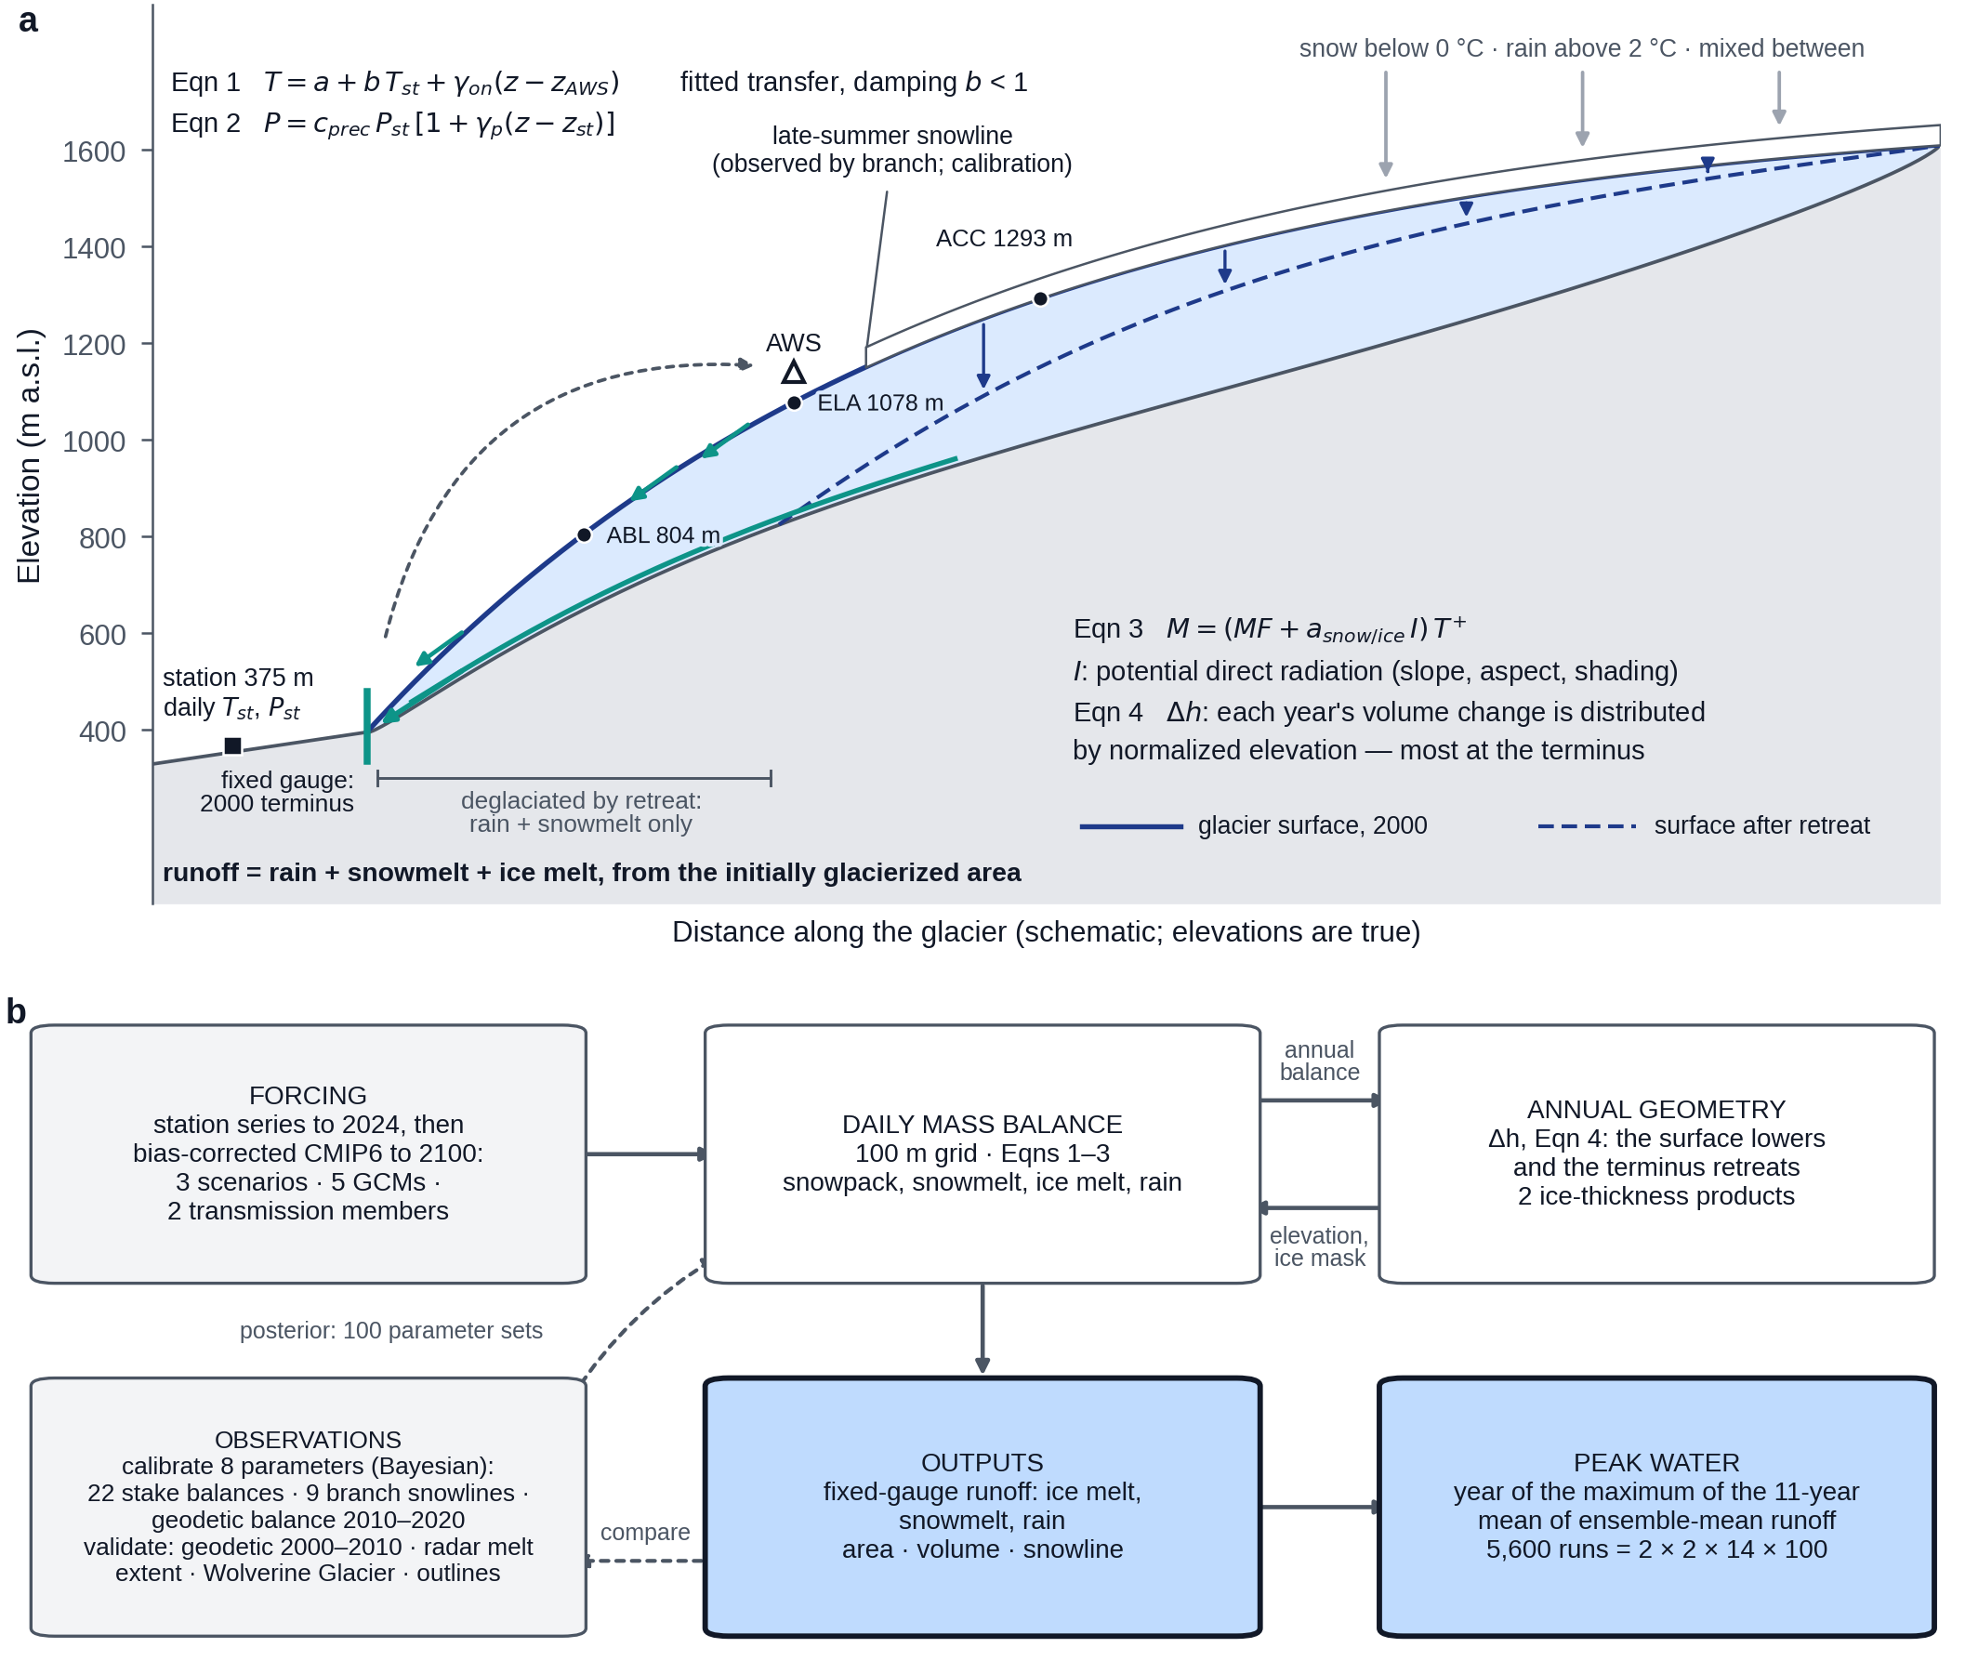
Fig. 2. Conceptual model. (a) Schematic long profile of Dixon Glacier; elevations are true, distance is schematic. Daily temperature and precipitation at the station (375 m a.s.l., square) are transferred to every glacier cell by Eqns (1) and (2), the temperature through a transfer fitted at the on-glacier weather station (AWS, triangle; dashed arrow). Precipitation (grey arrows) falls as snow, rain or a mixture according to air temperature. Melt of snow and ice follows Eqn (3) and leaves the surface as runoff (teal arrows), which is collected at a fixed gauge at the 2000 terminus (teal bar). The white band is the snow cover above the late-summer snowline. Dots are the mass-balance sites ABL, ELA and ACC at their surveyed elevations. Each year the volume change is distributed over the glacier by Eqn (4), most of it near the terminus (blue arrows), so the surface lowers from the solid to the dashed blue line and the terminus retreats. The ground exposed by retreat stays inside the gauged area and continues to yield rain and snowmelt but no ice melt. (b) The modelling chain. Grey boxes are inputs, white boxes the model, and blue boxes with a heavy edge the results. The forcing drives the daily mass-balance model on the 100 m grid, which exchanges the annual balance and the updated elevation and ice mask with the geometry model. The observations calibrate the eight parameters through 22 stake balances, 9 branch snowlines and the 2010–2020 geodetic balance, supply 100 posterior parameter sets to the model (dashed arrow), and are compared with its output in validation (dashed arrow). Peak water is computed from the fixed-gauge runoff of 5,600 runs. The figure is a schematic and shows no data; every count on it is generated from the model record.
Surface mass balance is computed daily for every cell of the 100 m grid with a distributed radiation-enhanced temperature-index model of the form of DETIM (Hock, 1999), the model applied to Eklutna Glacier by Geck and others (2021). Air temperature at a cell of elevation z on day t is
T(z,t) = a + b T_{st}(t) + γ_{on} (z − z_{AWS}), (1)
where T_{st} is the station temperature, a and b are the coefficients of the fitted transfer (Section 4.2), z_{AWS} = 1078 m is the AWS elevation and γ_{on} is an on-glacier lapse rate. Precipitation is
P(z,t) = c_{prec} P_{st}(t) [1 + γ_{p} (z − z_{st})], (2)
with a correction factor c_{prec} and a linear elevation gradient γ_{p} relative to the station elevation z_{st} = 375 m. Precipitation falls as snow below 0 °C and as rain above 2 °C, with a linear transition between, the form used by Huss and Hock (2015). Melt M (mm d⁻¹) is
M = (MF + a_{surf} I) T (T > 0), (3)
and zero otherwise, where MF is a melt factor, a_{surf} is a radiation coefficient that takes the value a_{snow} while a snowpack is present and a_{ice} otherwise, and I is the daily mean potential clear-sky direct solar radiation (W m⁻²) (Hock, 1999). I is computed once for every cell and day of year from the solar geometry, the slope and aspect of the cell, terrain shading (horizon angles in 24 azimuth sectors to 8000 m) and a clear-sky transmissivity of 0.75 raised to the barometric pressure ratio. Snowmelt is limited to the snow present; the fraction of a day’s melt energy left when the snowpack disappears melts ice. The balance of a cell is snowfall minus snowmelt and ice melt. Runoff is rain plus snowmelt plus ice melt summed over the initially glacierized area, the convention on which peak water is defined (Huss and Hock, 2018) and which Rounce, Hock, and others (2020) term fixed-gauge runoff: a cell that deglaciates continues to yield rain and snowmelt but no ice melt. Refreezing, firn as a distinct surface and the redistribution of snow by wind are not represented.
As a test of model structure, the classical degree-day model (Hock, 2003) is run through the same calibration and projection: a_{snow} = a_{ice} = 0 in Eqn (3), with separate degree-day factors for snow and ice, DDF_{snow} and DDF_{ice}, in place of MF (Section 4.4).

4.2 Temperature transfer
The station-to-glacier transfer was fitted on the 204 clean days of the two AWS seasons (Section 3.2). A linear regression of the daily mean AWS temperature on the station temperature, T_{AWS} = −2.679 + 0.718 T_{st}, explains 0.768 of the variance with a root-mean-square error (RMSE) of 1.27 °C (Fig. 3). The slope below one is the damping of near-surface air over the glacier by its katabatic boundary layer (Shea and Moore, 2010): the glacier warms by 0.718 °C for each degree at the station. A fixed lapse rate cannot represent this; lapse rates of −6.5 and −4.5 °C km⁻¹ applied over the 703 m elevation difference give RMSEs of 1.59 and 2.29 °C. A piecewise form in which the damping strengthens above a threshold (Shea and Moore, 2010) fits marginally better in sample (RMSE 1.25 °C; slope 0.792 below 9.3 °C and 0.453 above) but transfers worse between the two summers: fitted on one summer and tested on the other, its RMSE is 1.46 and 1.61 °C against 1.37 and 1.56 °C for the linear form, which is adopted.
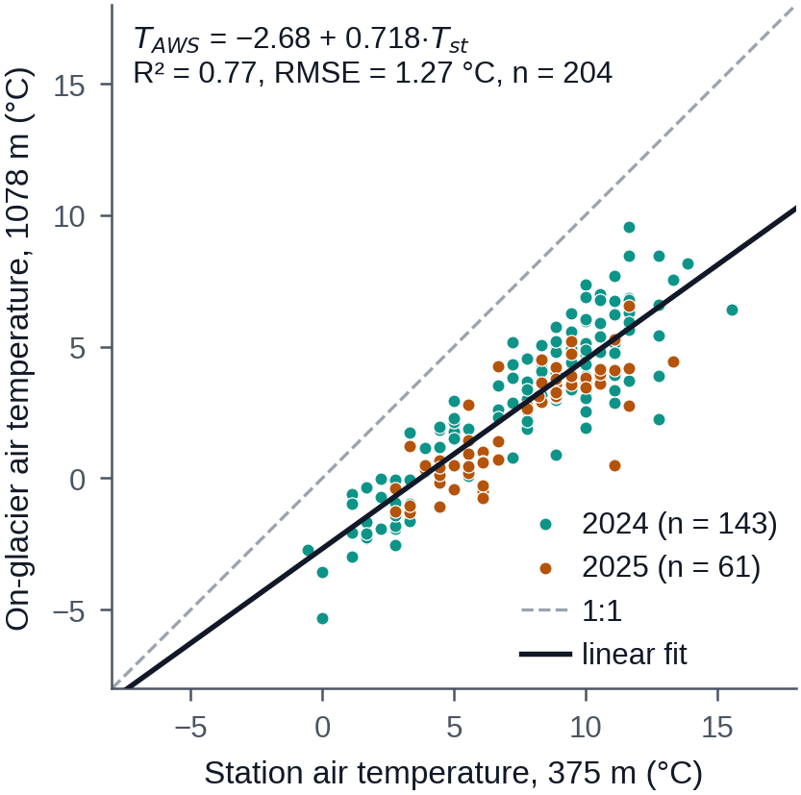
Fig. 3. Transfer of air temperature from the station to the glacier. Daily mean air temperature at the on-glacier weather station (1078 m a.s.l., the ELA site) against the same day’s mean at the Nuka SNOTEL station (375 m a.s.l.) for the 204 days with a complete record: 143 in 2024 (teal) and 61 in 2025 (amber), where the record ends with the sensor failure of 13 July 2025. The bold line is the least-squares fit, T_{AWS} = −2.679 + 0.718 T_{st} (R² = 0.768, RMSE = 1.27 °C), which is Eqn (1) at the elevation of the weather station. The dashed line is 1:1. The glacier is colder than the station on every day, and the slope below one shows that it warms by 0.718 °C for each degree at the station, the damping expected of a katabatic boundary layer (Shea and Moore, 2010). The two summers are offset about the common line: the 2024 days lie +0.24 °C and the 2025 days −0.56 °C from it on average.
The transfer is fitted before calibration and then held fixed. Degree-day melt is highly sensitive to the lapse rate (Gardner and Sharp, 2009), and on-glacier lapse rates differ from environmental values because of the cooling and damping over the ice (Carturan and others, 2015); fixing the transfer from observations keeps that sensitivity out of the melt parameters. Temperature scaling with elevation away from the AWS cannot be fitted from a single on-glacier site, so γ_{on} in Eqn (1) remains a calibration parameter with a prior of −4.5 ± 1.5 °C km⁻¹ from summer lapse rates measured over glaciers (Marshall and others, 2006; Gardner and others, 2009; Petersen and others, 2013). The fit uses melt-season data only and is applied in all seasons.

4.3 Geometry evolution
Glacier geometry evolves with the Δh parameterization of Huss and others (2010). At the end of each water year the glacier-wide balance over ice-covered cells is converted to a change in ice volume (ρ = 900 kg m⁻³) and distributed over the cells in proportion to the normalized thinning curve for large valley glaciers,
Δh = (h_{r} − 0.02)⁶ + 0.12 (h_{r} − 0.02), (4)
where h_{r} is the normalized elevation of a cell (0 at the highest cell, 1 at the lowest), rescaled so that the distributed change integrates to the year’s volume change. A cell whose thickness falls below 0.1 m is deglaciated and its unsatisfied loss is redistributed over the remaining ice. The surface of each cell is lowered by its thinning, which feeds back on temperature through Eqn (1). Thickening in a positive year is uniform, and advance is not represented. The scheme was tested on Dixon Glacier before use. It was driven only by the observed glacier-wide elevation change of Hugonnet and others (2021) (−1.26 m a⁻¹ for 2000–2010 and −0.95 m a⁻¹ thereafter), with no fitted parameter and no knowledge of the later outlines, and its area was compared with the four later digitized outlines (Sections 4.5 and 5.2). The potential-radiation field is kept at the initial topography.

4.4 Calibration
Eight parameters, θ = (MF, a_{snow}, a_{ice}, c_{prec}, γ_{p}, γ_{on}, β_{w}, σ_{extra}), are estimated in a Bayesian framework (Rounce, Khurana, and others, 2020; Sjursen and others, 2023): the posterior probability of θ is proportional to its prior probability times the likelihood of the observations given the model run with θ. The priors are truncated Gaussians (Table 2): MF from the degree-day factor for snow of Braithwaite (2008); a_{snow} and a_{ice} set around the Eklutna values of Geck and others (2021), with a_{ice} > a_{snow} required; c_{prec} and γ_{p} from the ranges used in global modelling (Huss and Hock, 2015); γ_{on} as in Section 4.2; β_{w} from the field estimate of the stake-branch accumulation excess (Section 3.4); and σ_{extra} half-normal. Temperature-index models suffer from equifinality, the existence of many parameter sets that fit the observations equally well (Beven, 2006; Sjursen and others, 2023), and the magnitudes of accumulation and ablation are only constrained separately when seasonal balances are used (Sjursen and others, 2023); the three groups below constrain different things.
Symbol | Meaning | Units | Prior (μ ± σ; bounds) | Prior source | Posterior median [5–95 %], Farinotti | IceBoost
MF | melt factor | mm d⁻¹ °C⁻¹ | 4.1 ± 1.5; [0.5, 12] | Braithwaite (2008) | 3.44 [2.05, 4.87] | 3.44 [2.04, 4.85]
a_snow | radiation coefficient, snow | mm d⁻¹ °C⁻¹ (W m⁻²)⁻¹ | 0.01 ± 0.005; [0, 0.05] | Geck and others (2021) | 0.0081 [0.0027, 0.014] | 0.0079 [0.0029, 0.013]
a_ice | radiation coefficient, ice | mm d⁻¹ °C⁻¹ (W m⁻²)⁻¹ | 0.03 ± 0.015; [0, 0.15] | Geck and others (2021) | 0.022 [0.012, 0.033] | 0.022 [0.012, 0.035]
c_prec | precipitation factor | – | 2 ± 0.75; [0.5, 5] | Huss and Hock (2015) | 1.71 [1.42, 2.02] | 1.71 [1.41, 2.04]
γ_p | precipitation gradient | m⁻¹ | 0.00015 ± 0.0001; [0, 0.0008] | Huss and Hock (2015) | 0.00017 [3.4e-05, 0.00032] | 0.00017 [3.2e-05, 0.00032]
γ_on | on-glacier lapse rate | °C m⁻¹ | −0.0045 ± 0.0015; [−0.01, −0.001] | Gardner and others (2009); Marshall and others (2006) | −0.0064 [−0.0076, −0.0052] | −0.0063 [−0.0076, −0.0051]
β_w | stake-branch winter accumulation excess | – | 0.2 ± 0.1; [0, 0.5] | field estimate (Section 3.4) | 0.215 [0.081, 0.356] | 0.207 [0.07, 0.35]
σ_extra | stake error inflation | m w.e. | 0 ± 0.3; [0, 1] | half-normal | 0.727 [0.59, 0.901] | 0.722 [0.588, 0.898]
Table 2. Calibration parameters, priors and posteriors (Section 5.1).
The likelihood is a product of independent Gaussian terms in three groups. (i) The 22 point balances (Section 3.4) are compared with the modelled balance of the stake cell over each observation’s own dates. The modelled winter portion is multiplied by (1 + β_{w}) to represent the accumulation excess of the stake branch relative to the glacier-wide model; a consistently placed stake does not necessarily capture the balance of the area around it (Zeller and others, 2022). The variance of each term is the assigned observation variance plus σ_{extra}², an inflation shared by all stakes, so that a systematic disagreement between the stakes and the geodetic record widens the stake uncertainties instead of distorting the physical parameters; the size of σ_{extra} is itself a result. Such disagreement is the general reconciliation problem between glaciological and geodetic balances (O’Neel and others, 2019; Zemp and others, 2019). (ii) The 2010–2020 geodetic balance enters with its published uncertainty. (iii) The 9 trusted branch snowlines (Section 3.5) enter with σ = max(50 m, the standard deviation along the line), compared with the modelled branch snowline, defined as the elevation quantile of the branch hypsometry equal to the branch’s snow-free area fraction (cells holding less than 0.01 m w.e. of snow).
The 2000–2010 geodetic balance is withheld because the station record of the 2000s is degraded: 21.0% of its temperatures are filled against 0.3% after 2010, and the filled days lower the decade’s summer mean by 0.48 °C (Section 3.2). The criterion is forcing quality and was fixed before calibration; the withheld decade serves as an out-of-sample test (Section 4.5). No snowline scene before 2011 passes the timing filter of Section 3.5, so none is available for either purpose. Each likelihood evaluation is a run of the coupled model over water years 1999–2025 on the evolving geometry (Section 4.3), initialized from the 2000 outline, with the geodetic balance accumulated over the initial area as in the geodetic product.
The posterior is sampled with the affine-invariant ensemble sampler emcee (Foreman-Mackey and others, 2013): 32 walkers for 5,000 steps, mean acceptance 0.44. The longest integrated autocorrelation time is 105 steps, 48 autocorrelation times per walker. After discarding the first 313 steps and thinning by 42, the posterior holds 3,552 samples, 1,433 of them effectively independent. The calibration is repeated on the IceBoost thickness track (3,456 samples, 1,396 effective). The degree-day variant (Section 4.1) is calibrated identically on the Farinotti track with θ = (DDF_{snow}, DDF_{ice}, c_{prec}, γ_{p}, γ_{on}, β_{w}, σ_{extra}), the prior of MF transferred to DDF_{snow}, DDF_{ice} = 7.0 ± 2.5 mm d⁻¹ °C⁻¹, centred between the best-fit values of Hock (1999) and spanning the reported range (Hock, 2003), and DDF_{ice} > DDF_{snow} required.

4.5 Validation design
Four tests use data the likelihood never saw. (i) The withheld 2000–2010 geodetic balance: the model is expected to fail there, in the direction of the forcing bias, and the size and sign of the failure are reported. (ii) The Sentinel-1 melt-extent series (Section 3.6): the modelled transient snowline, from a run at the posterior median, is paired weekly with the melt-extent elevation for the 175 weeks of May–September in the years the radar series covers, and the pooled correlation and RMSE are reported. The window is the melt season as defined by Geck and others (2021) and the period in which the two quantities describe the same surface: after the melt season the modelled snowline falls with new snow while wet surfaces keep the radar melt line high. The statistic over every week with data (May–October) is reported alongside, and the annual maxima are reported with the caution that eight years cannot constrain a correlation. (iii) Regional coherence: the modelled annual balance of Dixon Glacier at the posterior median is correlated with the observed glacier-wide balance of Wolverine Glacier for 2001–2025, and the posterior parameters are compared with values calibrated on Eklutna Glacier (Geck and others, 2021) and with the literature ranges behind the priors. (iv) The Δh hindcast of Section 4.3. Posterior-predictive checks of the three calibration groups use 50 evenly spaced posterior draws; the geodetic check uses the combined standard deviation of the observation and the posterior spread.

4.6 Climate projections
Figure 4 shows the design of the projection ensemble: the sources of uncertainty that are bracketed, the levels of each, and how each enters the results.
GCM series were bias-corrected to the station with the monthly method of GloGEM (Huss and Hock, 2015). For each GCM and calendar month an additive temperature offset and a multiplicative precipitation factor were fitted over the overlap of the historical run with the station record (1998-10-01 to 2014-12-31) and held constant into the future. Averaged over the year the offsets are 1.63–3.09 °C and the factors 2.84–3.14 across the five GCMs; corrected historical precipitation is 2.25–2.44 m a⁻¹ against 2.31 m a⁻¹ observed. Within a month the day-to-day variability of the GCM is preserved. The correction acts on the GCM-to-station step only; the station-to-glacier transfer and c_{prec} apply unchanged, so projected forcing enters the model exactly as the calibration forcing did. Each projection run uses the observed station series to the end of 2024 and the corrected scenario series from 2025-01-01: one continuous daily series from water year 2000 to 2100.
The two series are joined without adjustment. The correction matches each GCM to the station over 1998-10-01 to 2014-12-31 and does not require it to reproduce the decade that followed, so the decadal mean of the forcing need not be continuous at the hand-off. We measure the discontinuity for each of the 14 GCM–scenario pairs as the hand-off step: the 11-year mean June–August forcing temperature centred on 2030, which holds only GCM years (2025–2035), minus the mean centred on 2019, which holds only observed years (2014–2024) (Fig. 4b). Its size and its effect on the projected runoff are reported in Section 5.5.
The transfer of Section 4.2 was fitted on day-to-day variability. Whether the slower, decadal warming of the valley reaches the glacier at the same rate cannot be determined from two summers of AWS data. Between water years 2001–2010 and 2011–2020 the native summer (June–August) temperature at the station rose by 1.12 °C, while the glacier-adjacent station of Wolverine Glacier at 990 m warmed by 0.1 °C over the same decades. The projections therefore carry two transmission members. In the full member the slow component of warming passes through the transfer at its fitted slope, b = 0.72. In the damped member the excess of the 11-year running mean of temperature over its value at the hand-off from observed to projected forcing (2025-01-01) is multiplied by 0.208, the ratio of a slow-transmission slope of 0.15 to the fitted 0.72. The observed record is not modified, so both members run the calibration period identically, and the correction grows from zero at the hand-off to between −0.23 and −4.28 °C in the 2090s depending on the GCM and scenario (Fig. 4c).
The projection matrix is 2 thickness tracks × 2 transmission members × 14 GCM–scenario combinations × 100 posterior draws: 5,600 coupled runs of water years 2000–2100 (Fig. 4a; the two thickness fields are panels d and e). Each track draws from its own posterior; the same draw indices are used in every configuration, so differences between configurations are never sampling noise. Peak water is defined as in Huss and Hock (2018) and Rounce, Hock, and others (2020): the year of the maximum of the 11-year centred moving average of the ensemble-mean annual fixed-gauge runoff of a scenario. The window is not truncated at the ends of the series, so the last resolvable year is 2095; a run whose smoothed maximum lies in that year has not peaked within the projection and is counted as censored. Around the ensemble-mean value we report the distribution of the individual runs’ peak years and the mean and standard deviation of the peak years of the per-GCM ensemble means, the analogue of the GCM spread reported by Huss and Hock (2018). Two descriptive quantities of this study accompany every peak year: the plateau, the interval of years in which the smoothed ensemble-mean runoff lies within 2% of its maximum, and the censored fraction. The same code evaluates the benchmark of Rounce and others (2023) from its 12 GCM series. The contribution of each uncertainty axis to the timing is read from the peak year computed within each level of that axis (scenario, transmission member, thickness track and melt-model structure) with the other axes pooled. Its contribution to the volume of runoff is measured as a share of the variance among runs, the partition introduced by Hawkins and Sutton (2009) and applied to glacier projections by Marzeion and others (2020): for each year, the variance of the level means of the axis, with every other axis averaged out, divided by the total variance of smoothed annual runoff among the runs. The partition uses the 4,800 runs of the 4 GCMs that run all three scenarios, so that every combination of levels is present. Two differences from those studies follow from the design. The part of the variance that the five axes do not explain singly is kept and reported as the interaction between axes, not neglected. And internal variability is not separated, because each GCM contributes one realization; the share of the climate model includes it. Where a glacier geometry rather than a runoff series is shown, only the 4 GCMs that run all three scenarios are used, so that a difference between scenarios is not confounded by the sample of models, and thickness fields are never averaged across members; the number of members in which each cell still holds ice is mapped instead (Section 5.4).
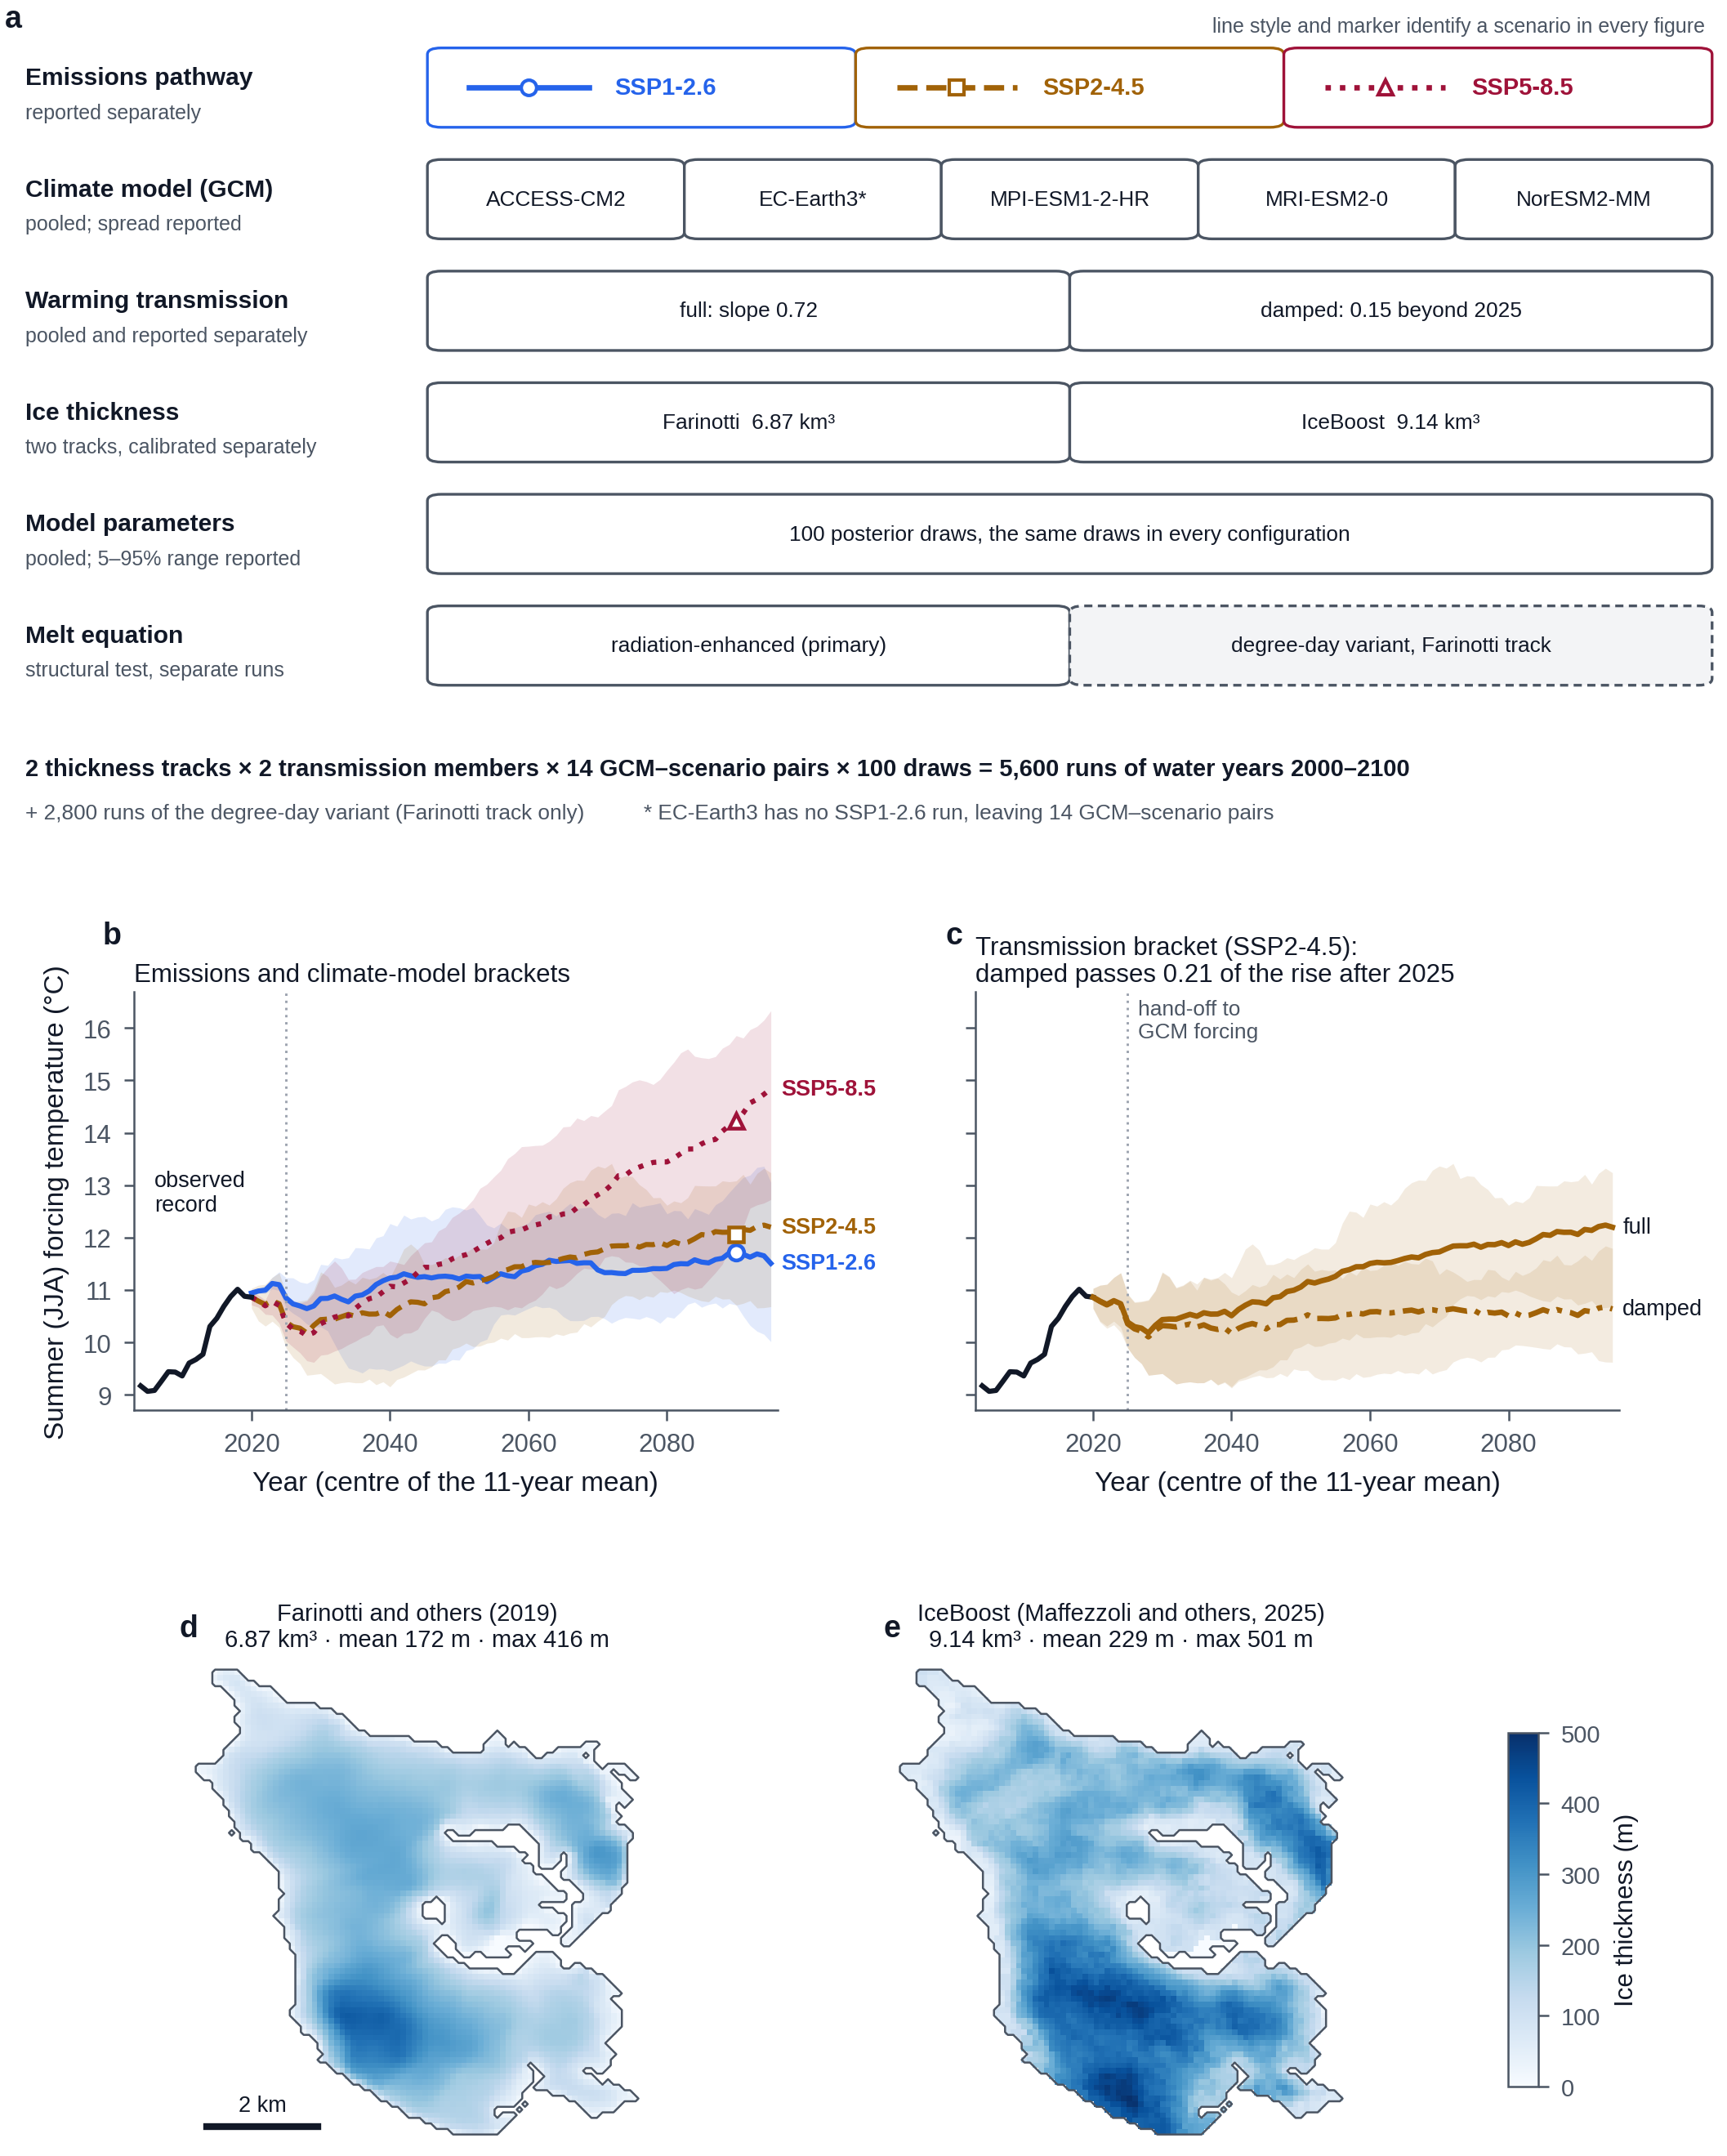
Fig. 4. Design of the projection ensemble: how each source of uncertainty is bracketed. (a) The six axes, their levels and how each enters the results. Emissions pathways are reported separately. Climate models (GCMs) are pooled and their spread is reported; EC-Earth3 has no SSP1-2.6 run, which leaves 14 GCM–scenario pairs. The two transmission members are pooled and also reported separately. The two ice-thickness products are separate tracks, each with its own calibration. Model parameters are 100 posterior draws, the same draws in every configuration. The melt equation is a structural test run separately on the Farinotti track (2,800 runs, dashed box). The product of the first five axes is 5,600 runs. In every figure a scenario keeps one colour, line style and marker: SSP1-2.6 blue, solid, circle; SSP2-4.5 ochre, dashed, square; SSP5-8.5 dark rose, dotted, triangle. (b) The emissions and GCM brackets drawn on the forcing itself: the 11-year centred mean of June–August air temperature at the station, observed (black) and, from the hand-off in 2025 (dotted vertical line), bias-corrected NEX-GDDP-CMIP6 output under full transmission. Coloured lines are means over GCMs, bands the range across GCMs, and markers sit at 2090. (c) The transmission bracket under SSP2-4.5: the full member (solid) and the damped member (dash-dot), which passes 0.21 of the slow warming after 2025; bands are the range across GCMs. From the 2010s to the 2090s the full member warms by 1.4, 1.9 and 4.1 °C under the three scenarios and the damped member by 0.4, 0.3 and 0.9 °C. The dip after the dotted line in b and c is the hand-off step: the mean centred on 2030 is −0.36 °C from the observed mean centred on 2019 on average (−1.48 to +0.61 °C; lower in 9 of 14 pairs). (d, e) The two ice-thickness products on the 100 m model grid and one colour scale: Farinotti and others (2019), 6.87 km³ with a mean of 172 m and a maximum of 416 m, and IceBoost (Maffezzoli and others, 2025), 9.14 km³, 229 m and 501 m.

5 Results

5.1 Calibrated parameters
The posterior medians and 5–95% ranges of the eight parameters are given in Table 2 and their distributions in Fig. 5. [ADVISER: the same posterior is drawn in two other forms, Fig. 6 and Fig. 7; one of the three will be kept.] The melt factor is 3.44 (2.05–4.87) mm d⁻¹ °C⁻¹, below the prior mean of 4.1 mm d⁻¹ °C⁻¹ and below the value of 5.5 mm d⁻¹ °C⁻¹ found for Eklutna Glacier (Geck and others, 2021). The radiation coefficient for ice, 0.0216 (0.0116–0.0334) mm d⁻¹ °C⁻¹ (W m⁻²)⁻¹, is half the Eklutna value of 0.0414, and the coefficient for snow, 0.0081, is close to the Eklutna value of 0.0098 (Geck and others, 2021). The precipitation factor is the best-constrained parameter: 1.71 (1.42–2.02), with a posterior 90% range 0.24 times the prior’s. The precipitation gradient is the least constrained (0.87 times the prior’s range). The on-glacier lapse rate is −6.4 °C km⁻¹, steeper than the prior mean by 1.2 prior standard deviations. The accumulation excess of the stake branch is 0.21 (0.08–0.36), inside the field estimate of 0.10–0.30. The stake error inflation is 0.73 (0.59–0.90) m w.e., several times the assigned uncertainties of 0.1–0.25 m w.e.
The posterior carries the trade-offs expected of a temperature-index model (Fig. 5): the melt factor is anticorrelated with both radiation coefficients (r = −0.73 with a_{snow}, −0.62 with a_{ice}), the ice coefficient is correlated with the lapse rate (r = 0.57), and the precipitation factor with its gradient (r = −0.47). Of the two error-model parameters, the error inflation σ_{extra} is uncorrelated with the six physical parameters (|r| ≤ 0.08), and the branch excess β_{w} is correlated most strongly with the precipitation factor (r = −0.38), which scales the same modelled winter accumulation at the stakes. The IceBoost track gives the same posterior: no median differs from the Farinotti track’s by more than 0.12 posterior standard deviations (Table 2). Over the calibration window the bed does not affect the surface balance; the thickness products differ in the projections (Section 5.4). The degree-day variant (Section 4.1) returns the same values for the five parameters it shares with the primary model, with DDF_{snow} = 5.3 (4.4–6.3) and DDF_{ice} = 7.7 (6.4–9.5) mm d⁻¹ °C⁻¹ (3,648 samples, 1,475 effective).
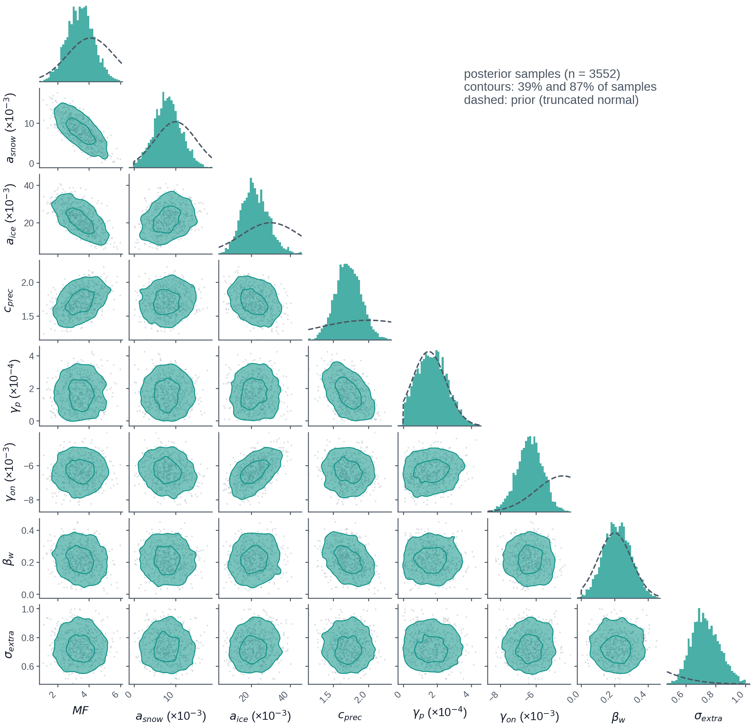
Fig. 5. Posterior distribution of the eight calibration parameters on the Farinotti thickness track (3,552 samples from the chain of Section 4.4). Panels on the diagonal show the marginal posterior of each parameter (histogram) and its truncated-normal prior (dashed line). Panels below the diagonal show the joint posterior of each pair: points are samples, and the two contours enclose 39% and 87% of them, the one and two standard-deviation masses of a two-dimensional Gaussian. The radiation coefficients and the lapse rate are multiplied by 10³ and the precipitation gradient by 10⁴; units are in Table 2. Every marginal has its maximum inside the prior range. Tilted contours are trade-offs between parameters: the melt factor against the radiation coefficients for snow (r = −0.73) and ice (r = −0.62), the ice coefficient against the lapse rate (r = 0.57) and the precipitation factor against its gradient (r = −0.47). Of the two error-model parameters, σ_{extra} is uncorrelated with the six physical parameters (|r| ≤ 0.08) and β_{w} trades against the precipitation factor (r = −0.38).
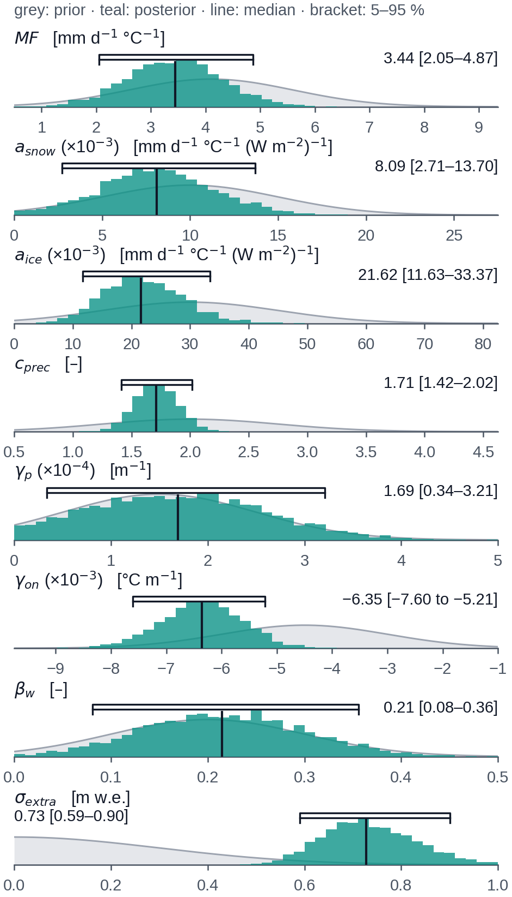
Fig. 6. The posterior of Fig. 5, one strip per parameter. The grey curve is the truncated-normal prior and the teal histogram the posterior. The vertical line is the posterior median and the bracket the 5–95% range; both are printed at the right. Each axis spans the support of the prior, clipped to the range of the samples where the prior is very wide. Display scales and units are given with each parameter name. A posterior much narrower than its prior marks a parameter the observations constrained: the precipitation factor most (a 90% range 0.24 times the prior’s) and the precipitation gradient least (0.87 times). The lapse rate moved away from its prior, to a value steeper than the prior mean by 1.2 prior standard deviations, and the stake error inflation σ_{extra} lies in the tail of its half-normal prior.
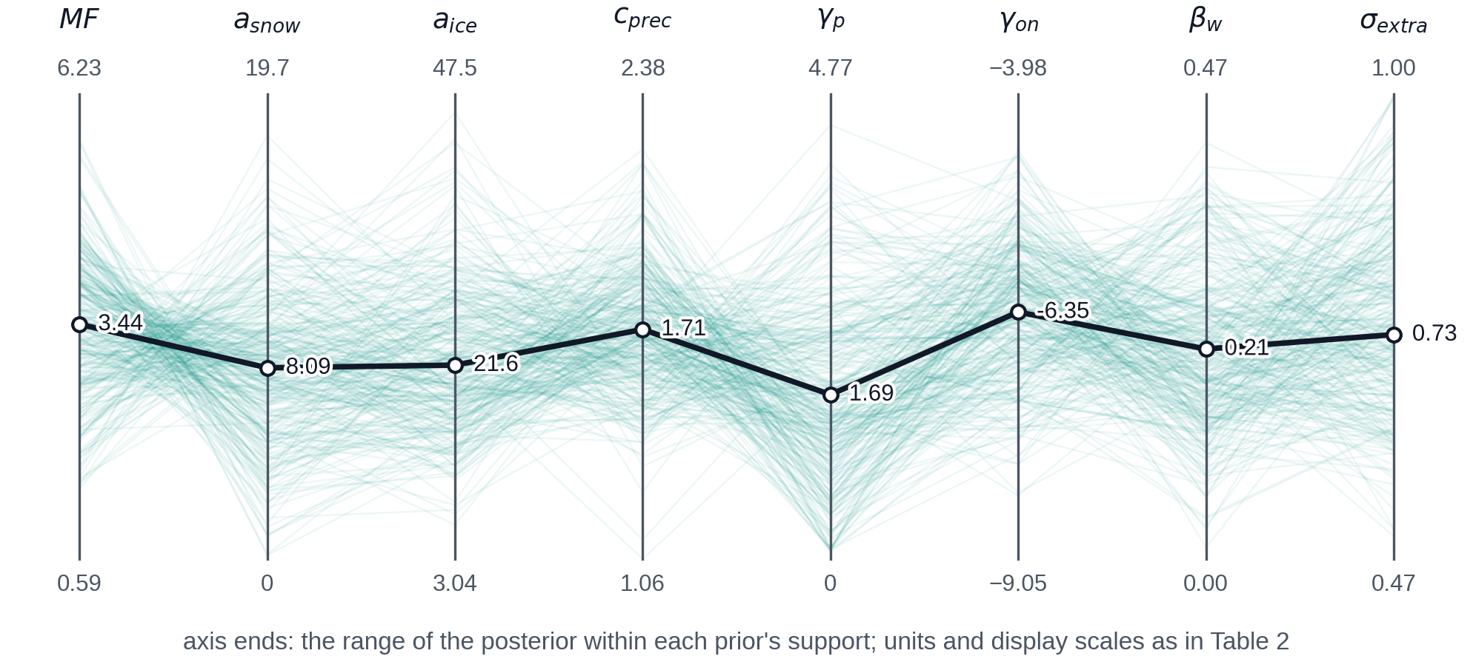
Fig. 7. The posterior of Fig. 5 as parameter sets. Each vertical axis is one parameter and spans the range of the posterior within the support of its prior; the end values are printed, with units and display scales as in Table 2. Each thin line is one posterior draw, a complete parameter set, for a random subset of the draws. The bold line joins the posterior medians, which are labelled. Lines that cross between two neighbouring axes show that the two parameters trade against each other, as between the melt factor and the radiation coefficient for snow; lines that run parallel show that they do not. The form is that of fig. 4 of Geck and others (2021), with posterior draws in place of the best combinations of a grid search.

5.2 Model fit and validation
The posterior-predictive fit to the three calibration groups is shown in Fig. 8. The 22 point balances are reproduced with a root-mean-square residual of 0.79 m w.e.; after the branch correction the observed winter balances still exceed the model by 0.32 m w.e. on average, and the observed summer balances are more negative than the model, with a mean residual of −0.21 m w.e. (Fig. 8a). The 9 trusted branch snowlines are matched with a mean residual of −20 m (observed minus modelled) and a root-mean-square residual of 50 m, −13 m on the north branch and −26 m on the south branch (Figs 8b, 9). The calibrated geodetic decade is reproduced within combined uncertainties but not centred: the model gives −0.51 (−0.66 to −0.26) m w.e. a⁻¹ for 2010–2020 against −0.81 ± 0.20 m w.e. a⁻¹ observed, a difference of 1.2 combined standard deviations (Fig. 8c). The surface observations agree with each other on the amount of melt and the geodetic record asks for about 0.3 m w.e. a⁻¹ more. The degree-day variant fits the same data equally well (stakes 0.81 m w.e.; snowlines −24 m mean, 48 m rms) and leaves the same geodetic gap (model −0.51 m w.e. a⁻¹, 1.3 combined standard deviations).
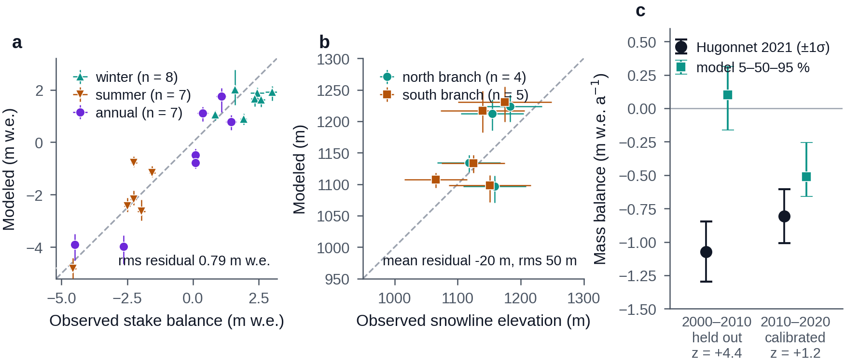
Fig. 8. Fit of the calibrated model to the three groups of calibration data. (a) Modelled against observed point mass balance for the 22 stake observations in the likelihood: winter (teal, upward triangles, n = 8), summer (amber, downward triangles, n = 7) and annual (violet circles, n = 7). Each symbol is the median of 50 posterior draws; vertical bars are their 5–95% range and horizontal bars the uncertainty assigned to the observation. The modelled winter balance includes the accumulation excess β_{w} of the stake branch. The root-mean-square residual is 0.79 m w.e. (b) Modelled against observed late-summer snowline elevation for the 9 trusted branch observations: north branch (teal circles) and south branch (amber squares). Horizontal bars are the uncertainty of the observed elevation and vertical bars the 5–95% range of the draws. The mean residual, observed minus modelled, is −20 m and the root-mean-square residual 50 m. Dashed lines in a and b are 1:1. (c) Glacier-wide geodetic mass balance of Hugonnet and others (2021) (black circles, ±1σ) and of the model (teal squares, median and 5–95% range) for the withheld decade 2000–2010 and the calibrated decade 2010–2020; z is their difference in combined standard deviations. The model reproduces the calibrated decade to within 1.2 combined standard deviations and is 4.4 too positive in the withheld decade, whose station forcing is biased cold by gap filling (Section 3.2).
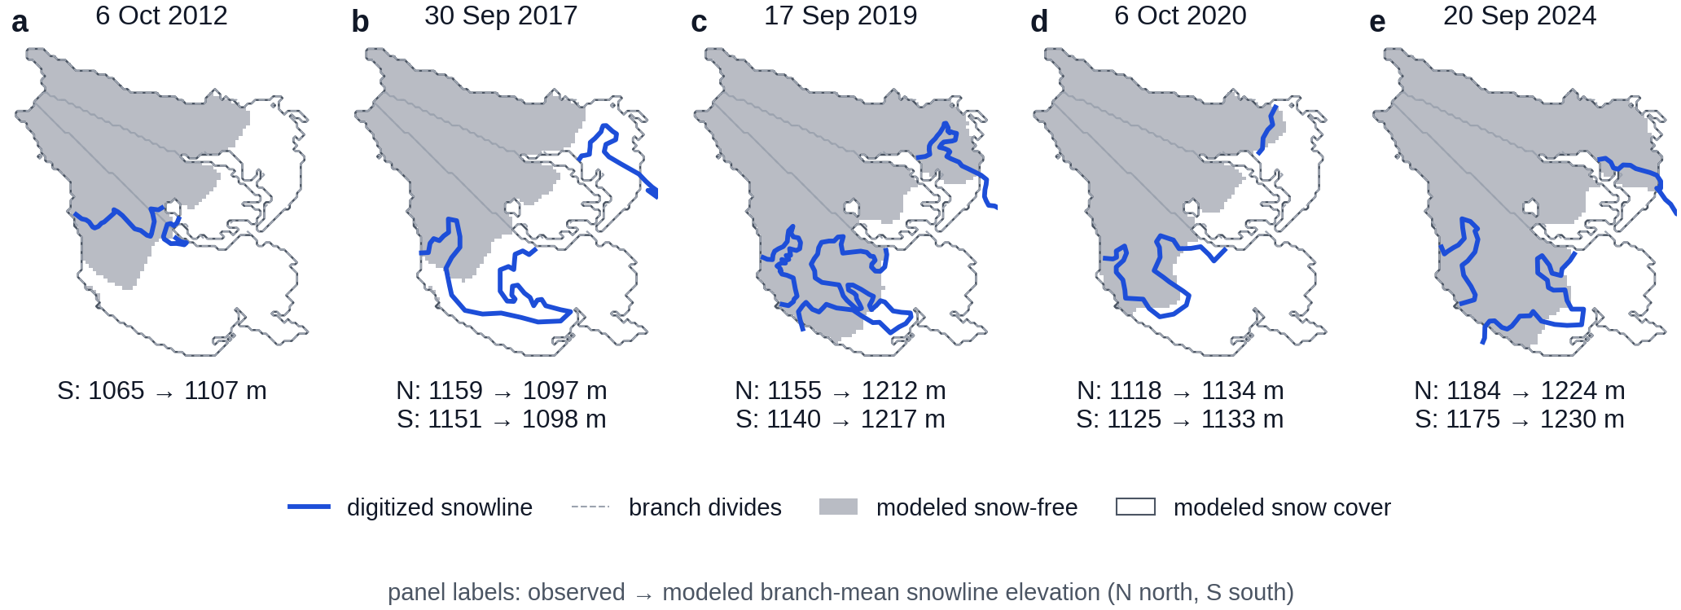
Fig. 9. Modelled snow cover and the digitized snowline on the 5 scene dates that enter the calibration (6 October 2012, 30 September 2017, 17 September 2019, 6 October 2020, 20 September 2024). Grey cells are snow-free in the model and white cells snow-covered (more than 0.01 m w.e. of snow), from a run at the posterior median under the observed forcing, drawn on the 2000 outline. The bold blue line is the snowline digitized from the Landsat or Sentinel-2 scene of that date, and thin dashed lines divide the three branches. Below each map, the observed and the modelled branch-mean snowline elevation are given as observed → modelled for the north (N) and south (S) branches; the middle branch is not used, because its digitized line wraps around a nunatak. The digitized line lies close to the modelled boundary between snow-free and snow-covered cells on both branches; the residuals are those of Fig. 8b.
The withheld decade fails as expected. For 2000–2010 the model gives +0.10 m w.e. a⁻¹ against −1.07 m w.e. a⁻¹ observed, 4.4 combined standard deviations too positive, the direction the cold-biased filled forcing of that decade implies (Section 3.2). The geometry scheme, driven by the observed thinning alone (Section 4.3), reproduces the four later outlines within 0.61 km² (1.5% of the area) on the Farinotti track and 0.53 km² (1.3%) on the IceBoost track, and its area lies below the digitized area at every epoch (Fig. 10d). The full coupled model run to water year 2025 gives a glacier area of 38.74 km² against 38.34 km² digitized for 2025, a difference of 1.0%. The modelled annual balance of Dixon Glacier is correlated with the observed glacier-wide balance of Wolverine Glacier with r = 0.71 over 2001–2025 (n = 25) and r = 0.79 from 2011 onward (Fig. 10a, b). The modelled transient snowline follows the Sentinel-1 melt-extent elevation through each melt season with r = 0.94 over 175 weeks of May–September and a root-mean-square difference of 87 m (Fig. 10c); over every week with data the values are r = 0.90 (n = 211, 102 m). The correlation of the annual maxima is 0.63 with n = 8 and a 95% interval of −0.13 to 0.93, which does not constrain it.
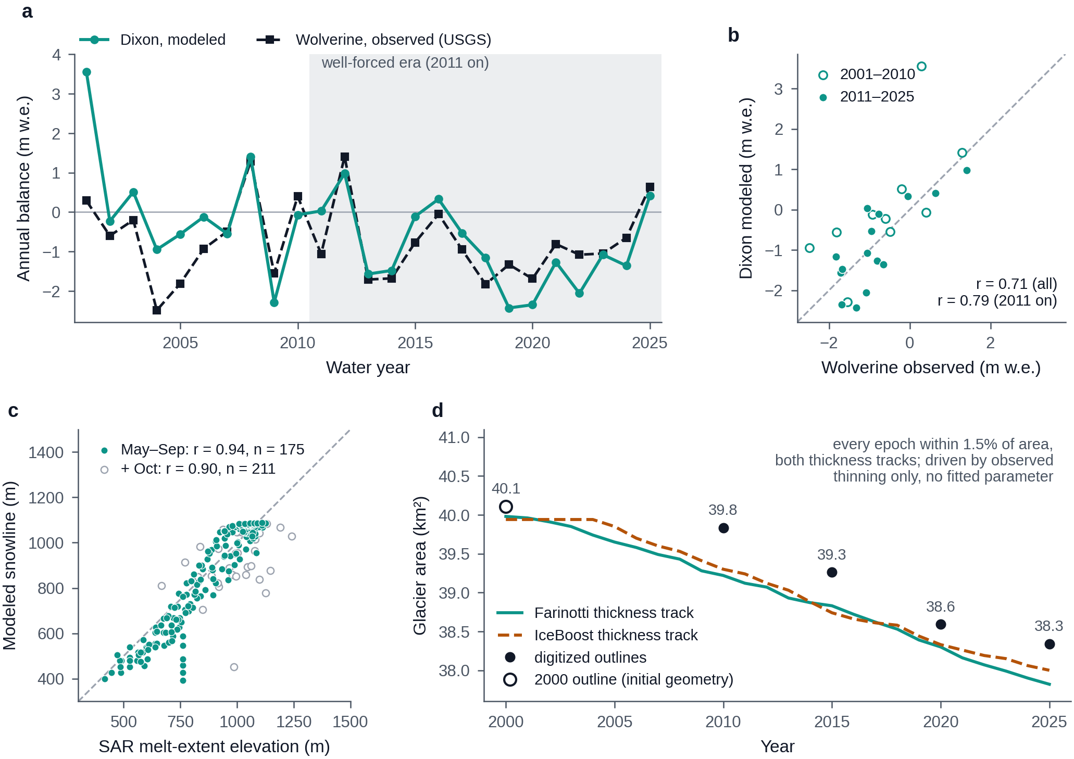
Fig. 10. Validation against records withheld from calibration. (a) Modelled annual glacier-wide mass balance of Dixon Glacier (teal circles, run at the posterior median) and the observed balance of Wolverine Glacier (black squares, dashed; USGS benchmark glacier 137 km to the northeast; O’Neel and others (2019)), water years 2001–2025. Shading marks the years from 2011, when the station forcing is nearly free of gap filling. (b) The same pairs as a scatter, open circles for 2001–2010 and filled circles for 2011–2025, with the 1:1 line (dashed): r = 0.71 for all 25 years and 0.79 from 2011. The two glaciers are different glaciers, so the test is of year-to-year coherence, not of magnitude. (c) Weekly modelled transient snowline elevation against the Sentinel-1 melt-extent elevation of Wells and others (2026), 2017–2024, with the 1:1 line. Filled circles are the weeks of May–September (r = 0.94, n = 175, root-mean-square difference 87 m); open circles add October (r = 0.90, n = 211), when new snow lowers the modelled snowline while wet surfaces keep the radar melt line high. (d) Test of the geometry scheme, 2000–2025. Lines are the glacier area given by the Δh parameterization of Huss and others (2010) (Eqn 4) when it is driven only by the observed glacier-wide thinning rates of Hugonnet and others (2021), with no mass-balance model and no fitted parameter: solid teal on the ice thickness of Farinotti and others (2019), dashed amber on the IceBoost thickness (Maffezzoli and others, 2025). Filled circles are the areas of the outlines digitized for 2010, 2015, 2020 and 2025, labelled in km²; the open circle is the 2000 outline from which both runs start. Both runs reproduce all four within 1.5% of the glacier area, less than the 2–5% uncertainty of manually digitized outlines (Paul and others, 2013), and lie below the digitized area at every epoch: the scheme retreats slightly too fast.

5.3 Hindcast mass balance and runoff, 1999–2025
Figure 11 shows the glacier-wide balance and runoff of the coupled model under the observed forcing for 100 posterior draws. Over water years 2011–2025 the median of the draws averages −0.87 m w.e. a⁻¹, with 4 of 15 years positive. The most negative year is 2019, −2.38 (−2.74 to −2.05) m w.e.; the warmest June–August of the station record is 2019 (13.8 °C); 2020 follows at −2.31 m w.e. The most positive year of the period is 2012 (+1.01 m w.e.; 2.73 m of precipitation at the station). Annual runoff averages 217 × 10⁶ m³ over 2011–2025 against 177 × 10⁶ m³ over 2001–2010, and reaches its maximum of 307 × 10⁶ m³ in 2019.
The 2000s carry the forcing problem of Section 3.2 into the hindcast: the median of the draws averages +0.10 m w.e. a⁻¹ over water years 2001–2010 where the geodetic record of 2000–2010 gives −1.07 ± 0.22 m w.e. a⁻¹ (the comparison over the geodetic window itself is in Section 5.2). Water year 2001 is the extreme, at +3.60 (3.01 to 4.14) m w.e.: 77% of its daily temperatures are donor-filled, its June–August mean of 6.3 °C is the coldest of the record (the next coldest is 8.0 °C), and 1.98 of its 2.9 m of precipitation falls at temperatures below 1 °C. The balance of that year is a property of the filled forcing.
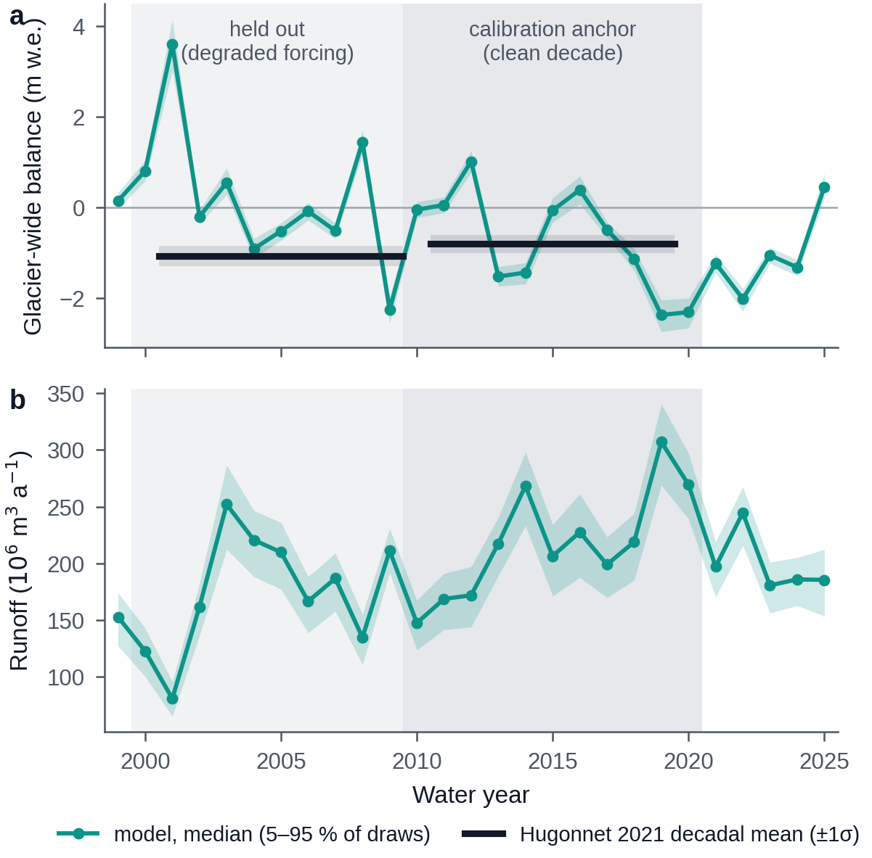
Fig. 11. Hindcast under the observed station forcing, water years 1999–2025. (a) Annual glacier-wide mass balance of the coupled model: median (teal line and circles) and 5–95% range (band) of the 100 posterior draws used in the projections. Black bars are the geodetic decadal means of Hugonnet and others (2021) with ±1σ (grey). Light shading marks 2000–2010, withheld from calibration because its forcing is degraded; darker shading marks 2010–2020, the decade of the calibrated geodetic balance. (b) Annual fixed-gauge runoff, same draws. In the calibrated decade the model is less negative than the geodetic mean, and in the withheld decade it is far too positive (Section 5.2); water year 2001 (+3.60 m w.e.) is an artefact of gap-filled temperatures (Section 5.3). Runoff is largest in 2019 (307 × 10⁶ m³), the year with the warmest summer of the station record.
In the modelled hydrograph of 2001–2020 (Fig. 12, matched-set mean of posterior-median runs) ice melt supplies 23% of annual runoff, snowmelt 44% and rain 34%; May–September carries 89% of the year’s runoff, mean discharge peaks on 6 August at 21.4 m³ s⁻¹, and December–February discharge averages 0.27 m³ s⁻¹.
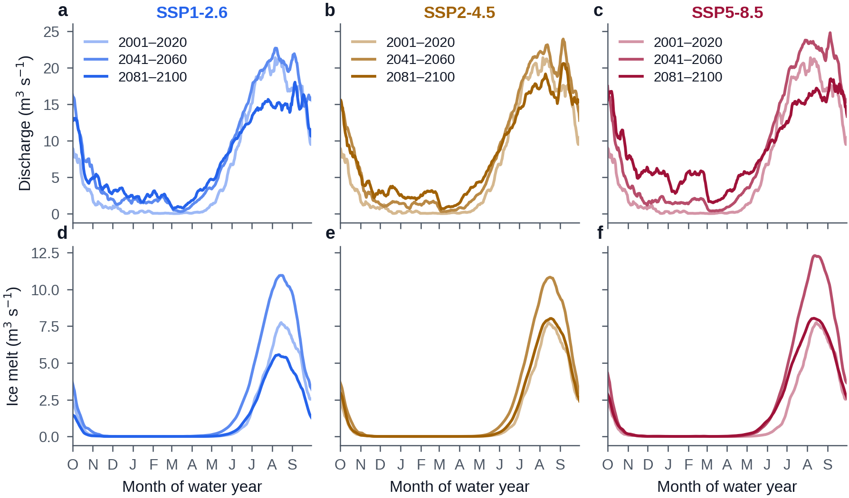
Fig. 12. Seasonal hydrograph by period. One column per scenario: SSP1-2.6 (a, d), SSP2-4.5 (b, e) and SSP5-8.5 (c, f). (a–c) Mean daily fixed-gauge discharge through the water year, October to September, for 2001–2020 (lightest line, observed forcing), 2041–2060 and 2081–2100 (darkest). (d–f) The ice-melt component alone, same periods. Each curve is the mean over the 4 GCMs that run all three scenarios, each run at the posterior-median parameters on the Farinotti thickness track with full transmission, as a 7-day smoothed climatology. Annual runoff rises from 201 × 10⁶ m³ in 2001–2020 to 262, 259 and 275 × 10⁶ m³ in 2041–2060, when ice melt is largest. By 2081–2100 the May–September share of annual runoff has fallen from 89% to 72, 73 and 62% and December–February discharge has risen from 0.27 to 2.5, 2.7 and 5.0 m³ s⁻¹, as the share of rain in annual runoff grows from 34% to 49–58%.

5.4 Projected glacier geometry
Pooled over both thickness tracks, both transmission members, all GCMs and all posterior draws, the median glacier area in 2100 is 25.0 km² (9.8–30.4 km², 5–95%) under SSP1-2.6, 26.6 km² (11.8–35.2 km²) under SSP2-4.5 and 22.8 km² (2.1–36.0 km²) under SSP5-8.5, that is 63, 67 and 57% of the 2000 area (Fig. 13a). By 2050 the medians are still 84, 89 and 88% of the 2000 area. No run loses the glacier entirely by 2100 under SSP1-2.6 or SSP2-4.5; 0.2% of runs do under SSP5-8.5. Ice volume falls on the Farinotti track from 6.91 km³ at the end of water year 2000 (the initial 6.87 km³ of Section 3.1 after one year of balance) to a median of 43, 46 and 37% of its 2000 value in 2100 under the three scenarios, and on the IceBoost track from 9.18 km³ to 55, 58 and 49% (Fig. 13b). The 5–95% ranges are wide: on the Farinotti track in 2100 they span 6–57% of the 2000 volume under SSP1-2.6 and 0–85% under SSP5-8.5.
The transmission members separate the geometry more than the scenarios do. Under SSP2-4.5 the median 2100 area is 19.0 km² with full transmission and 32.8 km² with damped transmission. On the matched set of four GCMs at the posterior median (Farinotti track, full transmission) the mean member area in 2100 is 17.5 km² under SSP1-2.6, 19.7 km² under SSP2-4.5 and 10.2 km² under SSP5-8.5: the low-emissions scenario ends the century with less ice than the middle one, on the matched set and in the pooled medians alike. Section 6.3 traces this to the forcing. In 2100 all four matched members still hold ice in 21% of the 2000 glacier cells under SSP1-2.6, 25% under SSP2-4.5 and 2% under SSP5-8.5, and none does in 40, 29 and 48% (Fig. 13c–e).
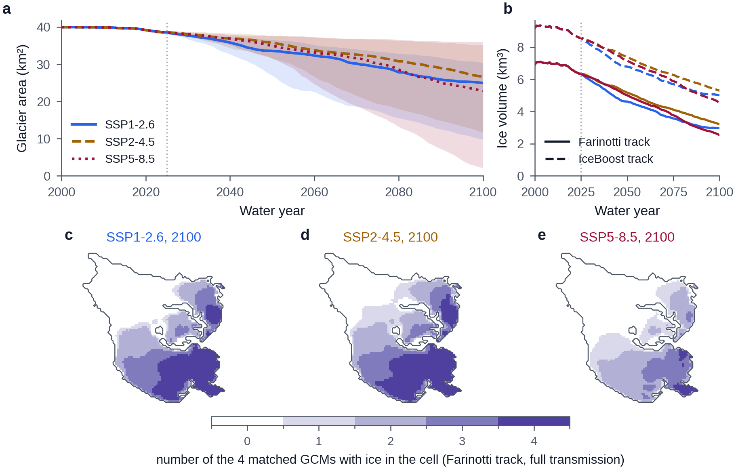
Fig. 13. Projected glacier geometry. (a) Glacier area: median (line) and 5–95% range (band) of all runs of a scenario, pooled over both thickness tracks, both transmission members, all GCMs and all posterior draws. SSP1-2.6 is blue and solid, SSP2-4.5 ochre and dashed, SSP5-8.5 dark rose and dotted; the dotted vertical line is the hand-off from observed to GCM forcing in 2025. (b) Ice volume, scenario medians for each thickness track: Farinotti (solid) and IceBoost (dashed), which start 33% apart and are never pooled. (c–e) Agreement on where ice remains in 2100: the number of the 4 GCMs that run all three scenarios in which each 100 m cell still holds ice (white, none; darkest purple, all four), for runs at the posterior median on the Farinotti track with full transmission, inside the 2000 outline. The bands in a are wider than the separation between the scenarios; the transmission members separate the geometry more than the scenarios do (Section 5.4). All four models keep ice in 21, 25 and 2% of the 2000 cells, in the upper south and north branches, and none keeps ice in 40, 29 and 48%, the lower glacier. The median area under SSP1-2.6 ends below that under SSP2-4.5 (Section 6.3).

5.5 Projected runoff and peak water
Pooled over both transmission members, the ensemble-mean runoff peaks in 2041 under SSP1-2.6, 2058 under SSP2-4.5 and 2063 under SSP5-8.5 (Fig. 14, Table 3). The crest broadens with emissions: the plateau within 2% of the maximum spans 2033–2043, 2051–2062 and 2061–2095, and 0, 1 and 13% of the runs have not peaked by 2095, the last year the 11-year window resolves. The per-configuration mean curves peak in 2040 ± 9, 2049 ± 24 and 2065 ± 27 (mean ± SD over configurations).
The two transmission members differ in kind, not only in timing (Table 3). Under full transmission the glacier has not reached peak water: 2 of the 2,800 runs peak by 2025, the mean curve peaks in 2041, 2058 and 2065, and the highest 20-year mean runoff is 1.21, 1.19 and 1.37 times the 2011–2024 mean. Under damped transmission the projected runoff is nearly flat. Its highest 20-year mean exceeds the 2011–2024 mean by factors of only 1.15, 1.06 and 1.10; its mean curve peaks in 2033 and 2051 and has not turned over by 2095 under SSP5-8.5; and 25, 39 and 40% of its runs place their smoothed maximum at or before 2025, in the warm decade that holds the hindcast’s runoff maximum (Section 5.3). For those runs the year of peak water has no sharp meaning: the curve is a plateau that has already begun. Over all 5,600 runs, 82% peak after 2025.
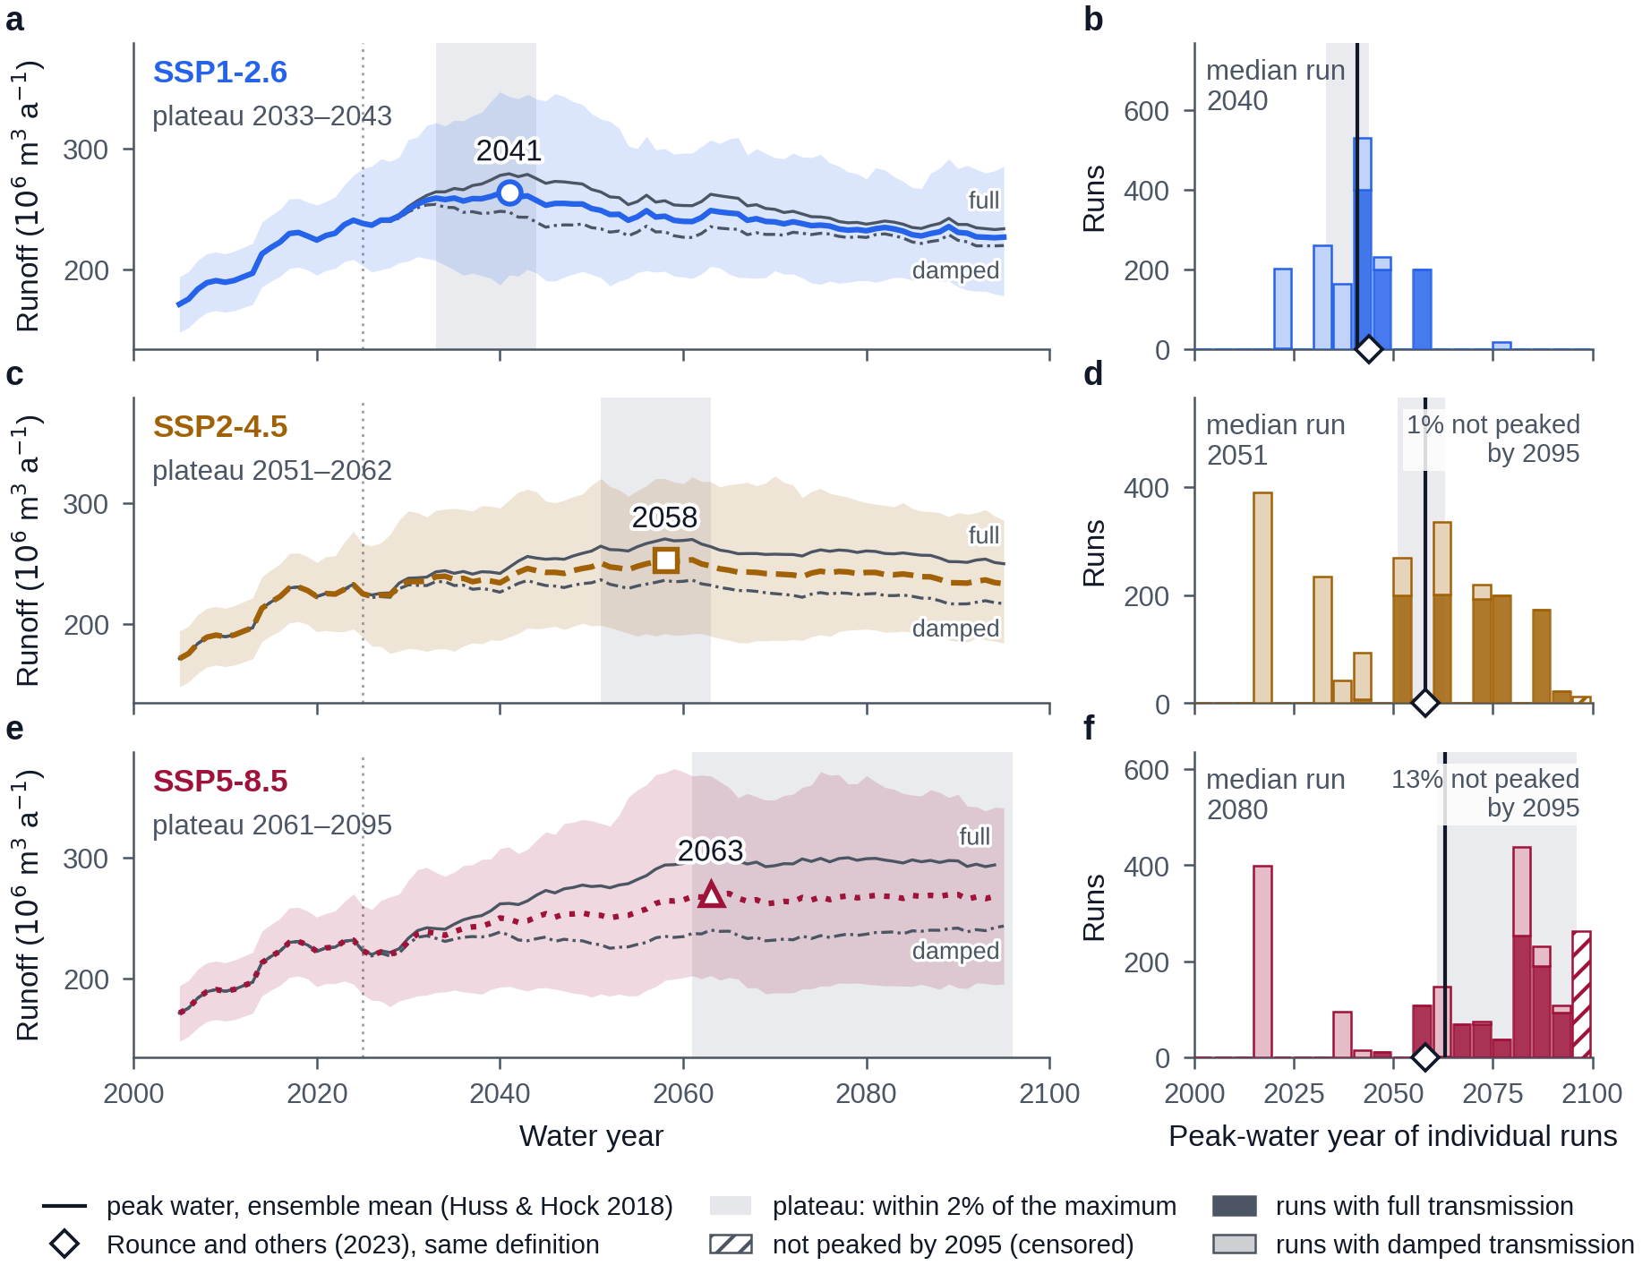
Fig. 14. Peak water by scenario: SSP1-2.6 (a, b), SSP2-4.5 (c, d) and SSP5-8.5 (e, f). (a, c, e) The 11-year centred moving average of annual fixed-gauge runoff. The bold coloured line is the mean of all runs of the scenario and the band the 5–95% range of the individual runs. Thin grey lines are the means of the two transmission members, full (solid) and damped (dash-dot), labelled at the right. The open marker and the year printed above it are peak water, the maximum of the bold line (Huss and Hock, 2018): 2041, 2058 and 2063. Grey shading is the plateau, the years in which the bold line is within 2% of its maximum. The dotted vertical line is the hand-off to GCM forcing in 2025; every run shares the observed forcing before it. (b, d, f) The peak years of the individual runs in 5-year bins, stacked by transmission member: full (solid colour) and damped (pale tint of the same colour). Hatched bars are runs that had not peaked by 2095, the last year the window resolves. The vertical line is the peak-water year of the left panel, grey shading the plateau, and the diamond the projection of Rounce and others (2023) evaluated with the same code (2044, 2058 and 2058). The crest broadens with emissions. The members separate after 2025: runoff rises to a mid-century peak under full transmission and stays nearly flat under damped transmission, which supplies all but 2 of the 990 runs that peak by 2025.
Scenario | Runs | Peak water (mean curve) | Plateau (within 2%) | Not peaked by 2095 | Median run (5–95%) | Peaked by 2025 | Peak / WY2001–2010 | WY2090s / peak | Rounce and others (2023)
SSP1-2.6 | all (1,600) | 2041 | 2033–2043 | 0% | 2040 (2024–2057) | 13% | 1.51 | 0.81 | 2044 (2053 ± 10)
 | full transmission (800) | 2041 | 2039–2044 | 0% | 2041 (2040–2057) | 0%
 | damped transmission (800) | 2033 | 2031–2035 | 0% | 2033 (2024–2046) | 25%
SSP2-4.5 | all (2,000) | 2058 | 2051–2062 | 1% | 2051 (2018–2088) | 20% | 1.49 | 0.85 | 2058 (2057 ± 14)
 | full transmission (1,000) | 2058 | 2056–2062 | 0% | 2070 (2051–2088) | 0%
 | damped transmission (1,000) | 2051 | 2024–2063 | 1% | 2034 (2018–2063) | 39%
SSP5-8.5 | all (2,000) | 2063 | 2061–2095 | 13% | 2080 (2018–2095) | 20% | 1.63 | 0.93 | 2058 (2059 ± 5)
 | full transmission (1,000) | 2065 | 2061–2090 | 16% | 2080 (2059–2095) | 0%
 | damped transmission (1,000) | 2095† | 2063–2095 | 10% | 2041 (2018–2095) | 40%
Table 3. Peak water by scenario, for all runs and for each transmission member: the year of the maximum of the smoothed ensemble-mean runoff (Huss and Hock, 2018; † not peaked by 2095), the plateau and the censored fraction (this study), the distribution of the individual runs’ peak years, and the share of runs peaking by 2025. For all runs: runoff at the peak relative to 2001–2010 and in the 2090s relative to the peak (medians over runs), and the benchmark of Rounce and others (2023) computed with the same code from its 12 GCM series (per-GCM mean ± SD in parentheses).
At the peak the smoothed ensemble-mean runoff of all runs is 263, 253 and 271 × 10⁶ m³ a⁻¹, that is 1.49, 1.44 and 1.54 times the 2001–2010 mean and 1.20, 1.16 and 1.24 times the 2011–2024 mean of 219 × 10⁶ m³ a⁻¹. In the 2090s the ensemble mean is 0.86, 0.92 and 0.99 of its peak and 1.03, 1.07 and 1.22 times the 2011–2024 mean; by member, the mean of 2081–2100 is 1.07–1.34 times the 2011–2024 mean under full transmission and 1.00–1.10 times under damped transmission. Evaluated with the same definition, the projection of Rounce and others (2023) peaks in 2044, 2058 and 2058; this study’s pooled years differ from those by −3, 0 and 5 years (Section 6.2).
The crest is broad because the components of runoff move in opposite directions (Fig. 15; matched-set mean of posterior-median runs, Farinotti track, full transmission). Smoothed ice melt rises from 42 × 10⁶ m³ a⁻¹ around 2010 to a maximum of 90, 75 and 89 × 10⁶ m³ a⁻¹ in 2041, 2051 and 2061 under SSP1-2.6, SSP2-4.5 and SSP5-8.5, and falls to 39, 51 and 58 × 10⁶ m³ a⁻¹ around 2090. Rain rises throughout, from 66 to 119, 120 and 163 × 10⁶ m³ a⁻¹, and exceeds snowmelt from 2026–2027 onward. Between the ice-melt maximum and 2090 the gain in rain makes up 20, 58 and 95% of the loss of ice melt, so total runoff around 2090 is 231, 246 and 280 × 10⁶ m³ a⁻¹ against 189 × 10⁶ m³ a⁻¹ around 2010.
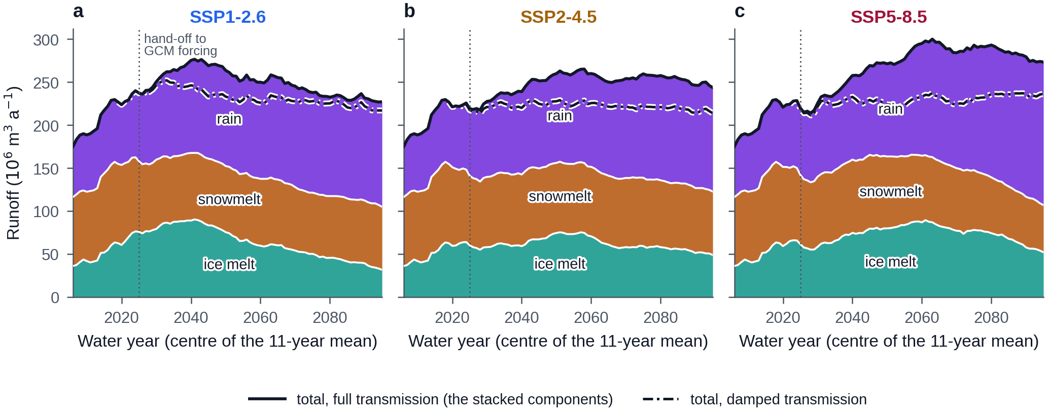
Fig. 15. Components of annual fixed-gauge runoff by scenario: SSP1-2.6 (a), SSP2-4.5 (b) and SSP5-8.5 (c). Stacked areas are ice melt (teal, bottom), snowmelt (amber) and rain (violet, top) under full transmission, separated by white lines and labelled. The solid black line is their sum, total runoff under full transmission; the dash-dot line is total runoff under damped transmission, drawn from the year it departs from the full member. All series are 11-year centred means of water-year totals, plotted at the centre year, and are the mean over the 4 GCMs that run all three scenarios, each run at the posterior-median parameters on the Farinotti thickness track. The dotted vertical line is the hand-off from observed to GCM forcing in 2025. Ice melt rises to a maximum in 2041, 2051 and 2061 and then declines, while rain grows through the century and is the largest component from the late 2020s; the second change makes up part of the first, most under SSP5-8.5 and least under SSP1-2.6, which flattens the total and broadens the crest. Under SSP2-4.5 and SSP5-8.5 the total dips after the hand-off, where the GCM summers are cooler than the observed decade (Section 5.5).
The hand-off from observed to GCM forcing is not smooth. The hand-off step (Section 4.6) averages −0.36 °C over the 14 GCM–scenario pairs, ranges from −1.48 to +0.61 °C and is negative in 9 of them; by scenario it averages −0.04, −0.45 and −0.52 °C (Fig. 4b). The smoothed runoff of the full member changes by −1, −4 and −6% between the window centred on 2019, the last that holds only observed years, and its minimum over the windows centred on 2020–2035 (Fig. 15). The step decides which damped runs peak in the observed decade. Every damped run that peaks by 2025 belongs to one of 5 pairs, those of MPI-ESM1-2-HR and MRI-ESM2-0, in which the step is −1.48 to −0.58 °C. In those pairs 94.5–100% of the damped runs peak by 2025; in the other 9 pairs none does. The shares of 25, 39 and 40% reported above are therefore 1 GCM of 4 under SSP1-2.6 and 2 of 5 under SSP2-4.5 and SSP5-8.5: they are set by the GCM, not by the parameter draws. A step down is not sufficient on its own, since the pair with a step of −1.0 °C has no run that peaks by 2025.
The seasonal hydrograph changes shape (Fig. 12). Relative to 2001–2020, annual runoff in 2041–2060 is 262, 259 and 275 × 10⁶ m³ against 201 × 10⁶ m³, and the ice-melt share rises from 23% to 28–30% before falling to 15–21% in 2081–2100. The day of peak mean discharge moves from 6 August to 6 September under SSP2-4.5 and SSP5-8.5. The May–September share of annual runoff falls from 89% to 72% under SSP1-2.6 and 62% under SSP5-8.5, while December–February discharge rises from 0.27 m³ s⁻¹ to 2.5, 2.7 and 5.0 m³ s⁻¹, and the rain share of annual runoff from 34% to 49–58%.

5.6 Uncertainty decomposition
Figure 16 shows the ensemble whole, one row for each of its 56 configurations. The rows of a thickness pair are nearly identical: their runoff relative to 2011–2024 differs by 0.01 at 2090 in the median pair and by at most 0.21, and 96% of the pairs share their peak year. The transmission blocks differ in kind, as in Section 5.5. The climate models differ most. At 2050 the configurations span 0.96–1.43, 0.95–1.43 and 0.89–1.45 times the 2011–2024 level under the three scenarios, and at 2090 0.93–1.28, 0.89–1.31 and 0.92–1.6. Under damped transmission the two GCMs in which the hand-off step sets the early peaks (Section 5.5), MPI-ESM1-2-HR and MRI-ESM2-0, run below the 2011–2024 level for 61–100% of the years after the hand-off.
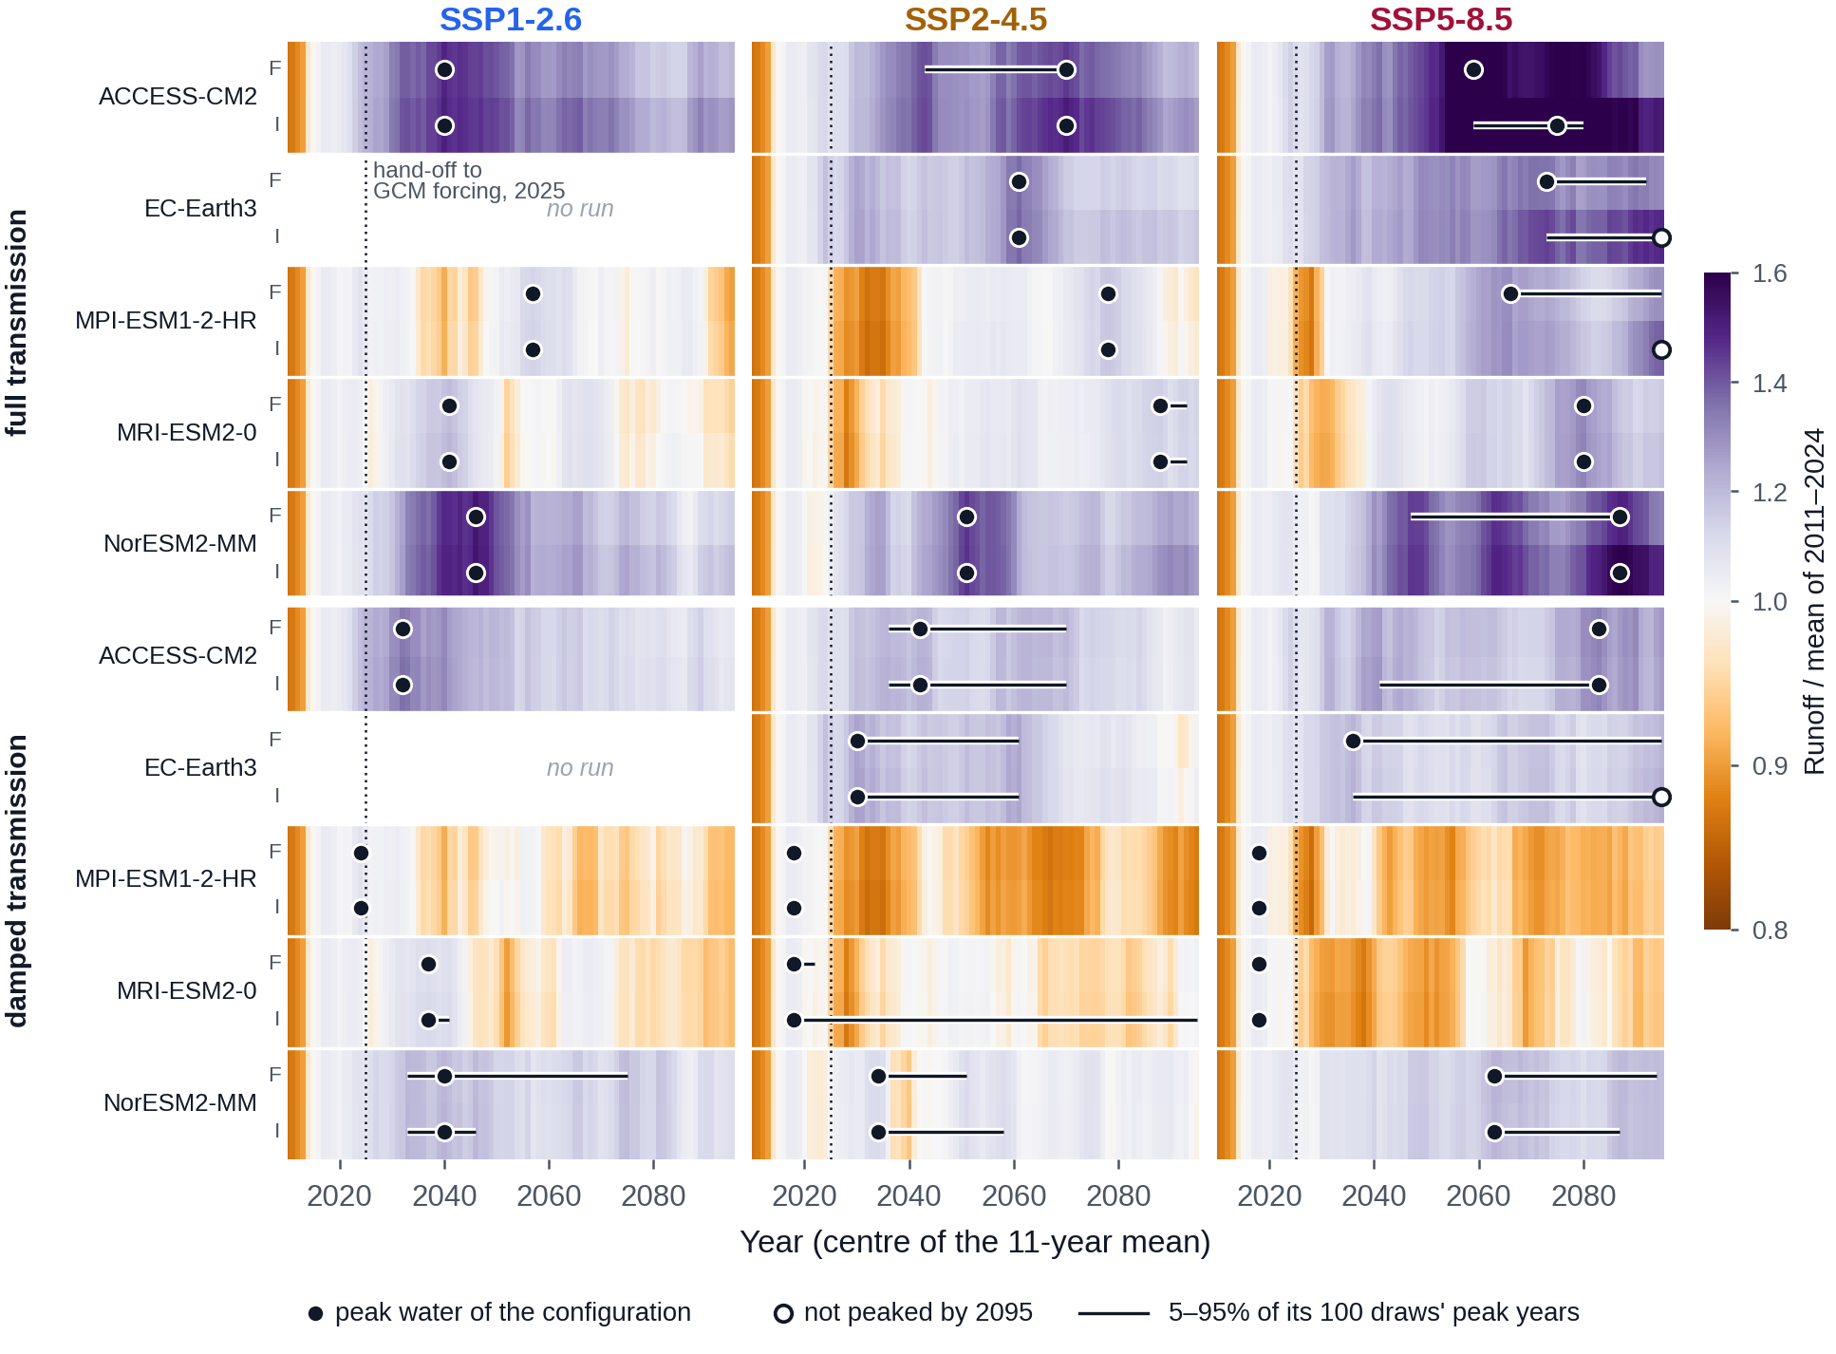
Fig. 16. The projection ensemble, configuration by configuration. One panel per scenario. Each row is one configuration, and the rows are nested by transmission member (upper block full, lower block damped), climate model (labelled at the left) and ice-thickness track (F, Farinotti; I, IceBoost), so that the layout is the design of the ensemble. Colour is the mean runoff of the configuration’s 100 posterior draws, as the 11-year centred mean of annual fixed-gauge runoff, divided by its own mean of 2011–2024: orange below that level, purple above it and white at 1. The dot is the peak-water year of the configuration (Huss and Hock, 2018), open at 2095 where its curve had not turned over. The bar is the 5–95% range of the peak years of its individual draws, the spread due to the model parameters. The dotted line is the hand-off to GCM forcing in 2025; to its left every row is the same run of the observed record. EC-Earth3 has no SSP1-2.6 run. Thickness pairs are nearly identical (96% share their peak year), the two transmission blocks differ in kind, and the climate models differ most. Under damped transmission MPI-ESM1-2-HR and MRI-ESM2-0, whose forcing steps down at the hand-off, run below the 2011–2024 level for 61–100% of the years after it: MPI-ESM1-2-HR stands at 0.89 of it at 2090 under SSP2-4.5.
Table 4 gives the peak year within each level of each uncertainty axis with the other axes pooled, in both readings, and Fig. S2 shows the same levels with the plateau of each. For the timing, two axes are large. The emissions pathway moves the ensemble-mean peak by 22 years between SSP1-2.6 and SSP5-8.5 and the median run by 40 years. The transmission members’ mean curves peak 8 and 7 years apart under SSP1-2.6 and SSP2-4.5, and under SSP5-8.5 the damped member’s has not turned over by 2095; their median runs differ by 8, 36 and 39 years, because the damped crest is flat and many of its runs peak in the observed decade (Section 5.5). Under SSP2-4.5, 39% of the damped runs peak by 2025, 36% in 2026–2044 and 14% in 2055–2064.
The other two axes are small wherever the crest is defined. The mean curves of the two thickness tracks differ by 0 and 0 years under SSP1-2.6 and SSP2-4.5; under SSP5-8.5 the Farinotti track peaks in 2063 while the thicker IceBoost track has not turned over by 2095, both inside the pooled plateau (Table 4). On the Farinotti track the degree-day variant’s ensemble-mean peak differs from the primary model’s by 0, 0 and 0 years under the three scenarios, and lies inside the primary model’s plateau in every case. The median-run reading gives differences of up to 14 years for thickness and 10 years for melt-model structure, under SSP2-4.5 and SSP5-8.5 only; these come from the flat damped crest, on which the median of the runs’ peak years is sensitive to small differences, and are not resolvable differences in timing. The axes act differently on the glacier geometry, where transmission dominates (Section 5.4).
For the volume of runoff the axes rank differently (Fig. 17). Before the hand-off every run shares the observed forcing, and the model parameters account for all of the variance among runs (standard deviation 17 × 10⁶ m³ a⁻¹ at 2015). The standard deviation rises to 43 × 10⁶ m³ a⁻¹ by 2050 and stays near that value. The climate model then explains the largest share: 57% of the variance at 2030, 52% at 2050 and 33% at 2090. The model parameters explain 27, 19 and 22%, the transmission members 1, 19 and 17%, and the emissions pathway 12, 0 and 14%. Ice thickness never explains more than 0.8%. Interactions between axes account for 3, 9 and 14%.
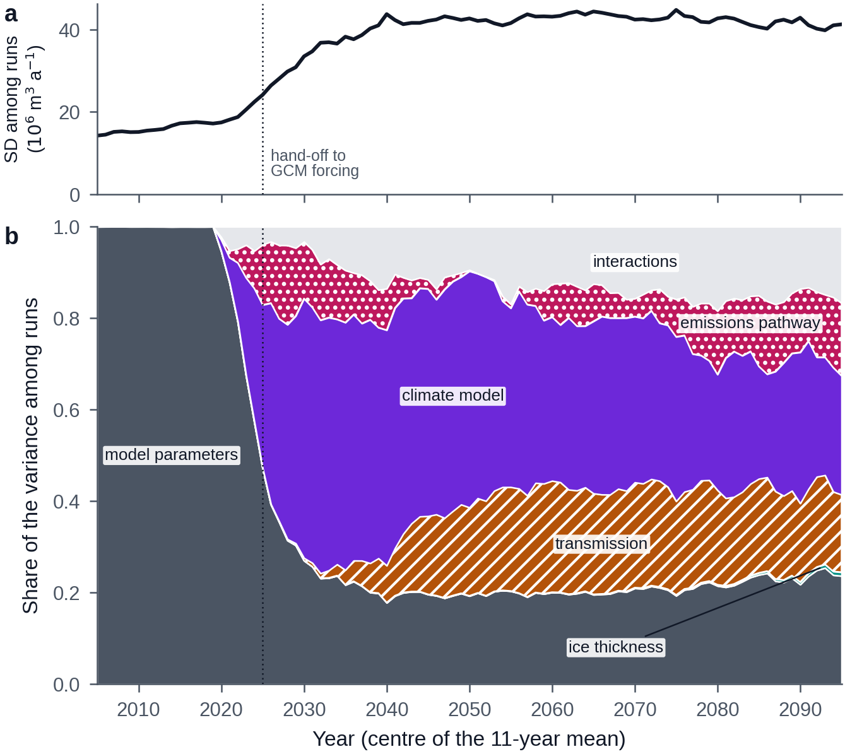
Fig. 17. Sources of the spread in projected runoff. (a) Standard deviation of smoothed annual runoff among the 4,800 runs of the balanced ensemble: 3 scenarios, the 4 GCMs that run all of them, 2 transmission members, 2 thickness tracks and 100 posterior draws. (b) Share of the variance among those runs explained by each axis: the variance of the level means of the axis, with every other axis averaged out, divided by the total variance. From the bottom the bands are the model parameters (dark grey), ice thickness (teal, a sliver), transmission (amber, hatched), climate model (violet), emissions pathway (magenta, dotted) and the interactions between axes (light grey); each is labelled. The dotted line is the hand-off to GCM forcing in 2025. The form is that of Hawkins and Sutton (2009) and, for glacier projections, of Marzeion and others (2020). Before the hand-off every run shares the observed forcing and the parameters are the whole spread. After it the climate model leads (57% at 2030, 52% at 2050 and 33% at 2090); the parameters and the transmission explain 19 and 19% at 2050 and 22 and 17% at 2090; the pathway matters only late (14% at 2090); ice thickness never exceeds 0.8%. Each GCM contributes one realization, so its share includes internal variability. The share of an axis with two or three levels measures the width of the bracket chosen here and is not a probability.
Axis | Level | SSP1-2.6 (mean curve / median run) | SSP2-4.5 (mean curve / median run) | SSP5-8.5 (mean curve / median run)
Transmission | full | 2041 / 2041 | 2058 / 2070 | 2065 / 2080
Transmission | damped | 2033 / 2033 | 2051 / 2034 | 2095† / 2041
Thickness | Farinotti | 2041 / 2040 | 2058 / 2061 | 2063 / 2066
Thickness | IceBoost | 2041 / 2040 | 2058 / 2051 | 2095† / 2080
Melt-model structure | radiation-enhanced (primary) | 2041 / 2040 | 2058 / 2051 | 2063 / 2080
Melt-model structure | degree-day variant (Farinotti track) | 2041 / 2040 | 2058 / 2051 | 2063 / 2065
Table 4. Peak year within each level of one uncertainty axis, other axes pooled: the Huss and Hock (2018) year of the ensemble-mean curve and the median of the individual runs’ peak years. † marks a level whose mean curve had not peaked by 2095. The melt-model rows compare the two melt equations on the Farinotti track alone.

6 Discussion

6.1 Model calibration
Three kinds of observation constrained eight parameters, and each did a different job. The geodetic balance fixed the mean mass loss of the calibrated decade, the point balances fixed its seasonal partition, and the trusted snowlines fixed where on the glacier the snow disappears in late summer. The posterior has an interior maximum along every axis (Fig. 5), the melt factor and the two radiation coefficients trading against each other and the precipitation factor against its gradient (Section 5.1), and the widths of the posteriors relative to their priors (Section 5.1) show which of the physical parameters the observations reached: the precipitation factor and the radiation coefficient for ice most, the precipitation gradient least. A single constraint would have left these trade-offs open (Beven, 2006), as Geck and others (2021) found for Eklutna Glacier, where the point balances alone were not well constrained even after a geodetic constraint. Sampling the posterior rather than searching a grid adds the joint distribution: the 100 draws used in the projections carry the trade-offs into the peak-water uncertainty instead of a single best set (Rounce, Khurana, and others, 2020; Sjursen and others, 2023).
The stakes and the geodetic record disagree in the way glaciological and geodetic series often do (O’Neel and others, 2019; Zemp and others, 2019). Two parameters absorb it. The branch excess β_{w} = 0.21 says the stake branch holds about a fifth more winter snow than the glacier-wide model, inside the field estimate; the error inflation σ_{extra} = 0.73 m w.e. says that, even so, the point balances scatter about the glacier-wide model by several times their measurement uncertainty. Without these terms the stakes would have pulled the melt parameters toward their own branch. With them, the stakes still shape the seasonal partition (their residuals are small in summer, Section 5.2) while their absolute levels are down-weighted. The size of σ_{extra} is itself a finding about how representative three sites on one branch are of a 38.34 km² glacier.
A residual of about 0.3 m w.e. a⁻¹ remains between the calibrated model and the geodetic decade (1.2 combined standard deviations, Section 5.2), and the degree-day variant leaves the same residual (Section 5.2), so it is not a property of the radiation term. The surface observations agree with each other on the amount of melt; the geodetic record asks for more mass loss than the surface budget provides. The terminus ends on land, so frontal ablation cannot supply the difference. The candidates are observational noise in the per-glacier geodetic estimate (p = 0.22 for a difference of this size), internal or basal ablation that the surface model does not represent, and snow accumulation lower than the stake branch implies over the rest of the glacier. The direction matters for the projection: if the model melts too gently by about 0.3 m w.e. a⁻¹, the peak is biased late. The full-transmission member works the other way, and the two are discussed together in Section 6.3.
Withholding the 2000s from the likelihood was decided on the quality of the forcing before any calibration (Section 4.4), and the withheld decade then failed in the predicted direction (4.4 combined standard deviations too positive, Section 5.2), with water year 2001 as its extreme (Section 5.3). Had the decade been included, the calibration would have compensated a cold artefact of the fill cascade with warmer melt parameters. The cost of the choice is that one geodetic value anchors the absolute balance of the calibration, and the residual just discussed is the price of that anchor being single.
The transfer of station temperature to the glacier (Section 4.2) was fitted before calibration so that the station-to-glacier temperature gradient could not trade against the melt factor (Gardner and Sharp, 2009); the on-glacier lapse rate above and below the weather station remains a calibration parameter and does trade against the ice coefficient (Section 5.1). Its damping slope of 0.718 is what an on-glacier boundary layer produces (Shea and Moore, 2010; Carturan and others, 2015). It was fitted on two melt seasons and is applied in every season and every future summer. Whether the damping holds as the glacier and its boundary layer shrink is not known, and the transmission members of Section 4.6 bracket the decadal version of the same question.
The degree-day variant answers the structural question the calibration design left open. Without a radiation term the two melt factors take the values the literature reports for snow and ice (Hock, 2003), the shared parameters do not move, the fit is as good, and the peak years agree (Sections 5.1, 5.2, 5.6). The radiation term was retained because models with a shortwave term transfer better across decades than plain degree-day models (Gabbi and others, 2014), but on this glacier and these data the difference between the two equations is smaller than the difference between winter-balance treatments, as Réveillet and others (2016) found on annual balances in the Alps; the melt equation is not where the uncertainty of this projection lives.

6.2 Comparison with other studies
Evaluated with one definition and one code, the global projection of Rounce and others (2023) and this study’s pooled ensemble place Dixon Glacier’s peak water −3, 0 and 5 years apart under SSP1-2.6, SSP2-4.5 and SSP5-8.5 (Table 3), from two chains that share no parameter and no observed forcing, and among their calibration data only the geodetic record of Hugonnet and others (2021), used here for one decade and there for the per-glacier mean. For the central year, therefore, local data do not change the answer of the global model; they attach an uncertainty to it and a hydrograph behind it. The difference is in the shape of the crest. The global model’s twelve GCMs agree on the year to within ± 5 years under SSP5-8.5; this study’s configurations spread over ± 27 years, its plateau runs from 2061 to 2095, and 13% of its runs have not peaked by 2095. Most of that breadth comes from the transmission members (Section 6.3), an uncertainty the global model does not carry because it has no on-glacier record to raise it; the remainder reflects a calibration to surface observations that melts more gently than a geodetic-only calibration (Section 6.1) and daily forcing through a fitted boundary-layer transfer.
The runoff curves differ more than the years do (Fig. 18). In the observed era the global model’s runoff is lower: 167 × 10⁶ m³ a⁻¹ over the windows centred on 2005–2020 against 203 × 10⁶ m³ a⁻¹ here, which is 22% higher. From that level the global model rises to its peak by factors of 1.27, 1.34 and 1.47 under the three scenarios and this study by 1.3, 1.25 and 1.33. The two part after the peak. By 2090 the global model has fallen to 0.79, 0.77 and 0.7 of its peak, which is 1.0–1.04 times its level of 2005–2020, while this study’s ensemble mean holds 0.88, 0.92 and 1.0 of its peak, 1.14–1.33 times its level of 2005–2020. A likely cause is the part of runoff that is not ice melt. Here ice melt supplies 23% of runoff in 2001–2020, and rain grows through the century as snowfall turns to rain (Section 5.5), which holds the total up while ice melt declines; a model with less precipitation over the glacier would lose more of its runoff with its ice. The components of the global projection were not examined, so this is a hypothesis. For the diversion the two projections agree on the floor, runoff late in the century at or above that of 2005–2020, and differ on the margin above it.
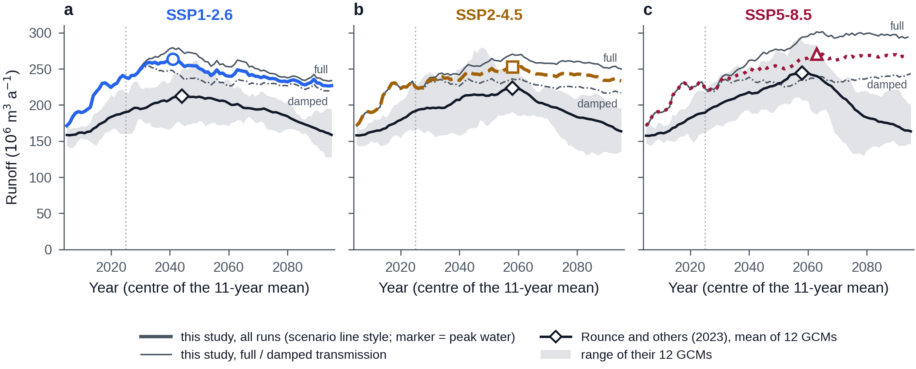
Fig. 18. Projected runoff of Dixon Glacier in this study and in the global projection of Rounce and others (2023), by scenario: SSP1-2.6 (a), SSP2-4.5 (b) and SSP5-8.5 (c). Every curve is the 11-year centred mean of annual fixed-gauge runoff from the initially glacierized area, plotted at the centre year and computed with the same code. The bold coloured line is the mean of all runs of this study, with its peak-water year marked (circle, square or triangle); thin grey lines are the means of its full (solid) and damped (dash-dot) transmission members. The black line is the mean of the 12 GCMs of the global projection, with its peak-water year marked (diamond), and the grey band is the range of the smoothed curves of its individual GCMs. The dotted vertical line is 2025, where this study passes from observed to GCM forcing. The peak-water years of the two projections differ by −3, 0 and 5 years. The global model runs 22% lower in the observed era and falls to 0.7–0.79 of its peak by 2090, where this study holds 0.88–1.0. The global projection is in calendar years and this study in water years.
The regional picture is consistent. Geck and others (2021) reconstructed 35 years of Eklutna Glacier and found its discharge still rising; Dixon’s hindcast runoff is higher over 2011–2025 than over 2001–2010 (Section 5.3) and under full transmission every scenario keeps it rising for at least 14 more years. The modelled balance of Dixon tracks the observed balance of Wolverine Glacier (r² = 0.5 over 2001–2025; 0.62 after 2010, when the forcing is clean), less closely than Eklutna’s modelled balance did (r² = 0.73 over 1985–2019, Geck and others (2021)), but with the coherence expected of three glaciers in one maritime climate. On the Kenai Peninsula glacier area fell by about 12% between 1986 and 2016 (Yang and others, 2020); Dixon’s area changed by −4.4% between 2000 and 2025 and its surface elevation by −1.1 m a⁻¹, the slow areal response of a large, thick outlet glacier to a mass loss that is already large. Peak water is expected later in Alaska than in most glacierized regions because its glaciers are large (Huss and Hock, 2018; Geck and others, 2021); a crest between the 2040s and the 2090s for a 38.34 km² glacier is that expectation at the scale of one glacier.

6.3 Sources of uncertainty
Two axes set the timing. The emissions pathway moves the ensemble-mean peak by 22 years and the median run by 40 years; the transmission of slow warming to the glacier decides whether there is a peak to time at all (Section 5.5). Within a scenario the configurations, that is the GCMs, the two thickness products and the two transmission members, spread the mean-curve peak by ± 24 years under SSP2-4.5, and the 100 posterior draws within one configuration spread its peak years by 15 years (5–95%). Parameter uncertainty, the part local data can reduce, is thus smaller than the configuration spread, and both are smaller than the pathway and the transmission question together. The volume of runoff ranks the axes differently (Section 5.6). At 2050 the climate model explains 52% of the variance among runs, the model parameters 19%, the transmission 19% and the pathway 0%; by 2090 the pathway has reached 14% and the climate model still leads with 33%. Marzeion and others (2020) found the emission scenario to be the largest source of uncertainty in global glacier mass by 2100, and natural variability to be small globally but potentially large regionally. At the scale of one glacier and one grid cell the ranking is the regional one: the choice of climate model, with the internal variability that a single realization of each cannot separate from it, outweighs the pathway until late in the century.
Ice thickness governs how long the glacier lasts, not when its runoff peaks: the two products, 33% apart in volume, give median runs that peak within 14 years of each other while ending the century with 46 and 58% of their 2000 volume under SSP2-4.5 (Sections 5.4, 5.6). This is the expected behaviour: the timing of the peak is set by the balance between rising melt and shrinking area on the surface, which both products share, while the volume beneath decides how far the decline runs. The two products bracket bed reality without local measurements to arbitrate (Farinotti and others, 2019), and carrying both through every projection reports that uncertainty rather than averaging it.
The transmission bracket is the axis this study adds to the usual set, and it matters as much as the pathway. The full member passes the slow warming through the fitted daily transfer; the damped member passes 0.21 of the warming beyond the present, on the evidence that the valley station warmed by 1.12 °C between the two calibration decades while the glacier-adjacent Wolverine station warmed by 0.1 °C (Section 4.6). Both members run the observed period identically, so both reproduce the calibrated decade; they part in 2025. Under full transmission runoff rises to 1.19–1.37 times its 2011–2024 mean and peaks between 2041 and 2065. Under damped transmission it never exceeds 1.15 times that mean, and in 25–40% of the runs the warm decade just observed is not surpassed (Section 5.5). Which runs those are is set by the hand-off step of the GCM, not by the model parameters (Section 5.5). The physical statement behind the second case is simple: the decade 2014–2024, with the heat of 2019, already produced runoff close to what a glacier of this size can deliver if little further warming reaches it. The bracket is wide because the evidence for it is thin, one station pair over two decades, and it is kept as two members rather than resolved because resolving it needs on-glacier records that do not yet exist; a few more summers of the AWS at the equilibrium line would narrow it more than any refinement of the model. A damped transmission cannot persist once the glacier and its boundary layer are small, so the damped member is an upper bound on retained ice and a lower bound on future runoff.
The scenarios themselves carry a feature a reader will otherwise mistake for an error. On the matched set the model ends the century with less ice under SSP1-2.6 than under SSP2-4.5 (Section 5.4). The cause is in the forcing: at the Dixon grid point the bias-corrected SSP1-2.6 summers are warmer than the SSP2-4.5 summers by +0.62 °C over 2025–2040 and +0.35 °C over 2040–2060, all 4 matched GCMs agreeing in sign, and only after 2060 does the low-emissions scenario become the cooler one (−0.11 and −0.40 °C). A glacier loses most where it is warmest and does not recover the loss, so the pathway that is warmer early ends smaller. The near-term warming of the stringent-mitigation pathways is assessed to come predominantly from the reduction of sulphate aerosol, an effect that levels off after 2040 (Szopa and others, 2021), and clean-air policies alone are projected to add 0.8 °C of Arctic warming by 2050 (Salzen and others, 2022). This study takes the published forcing as given and attributes nothing; it notes that the crossover is a property of the inputs, that the four models agree on it, and that a single realization per model cannot separate it from internal variability with confidence.
Two further assumptions act on the projections without a member to bracket them. The monthly bias correction is held constant into the future, the standard assumption of glacier modelling with corrected GCM output (Huss and Hock, 2015), as the downscaling itself assumes a constant reference period (Thrasher and others, 2022). And the geodetic residual of Section 6.1 means the calibrated model may melt too gently by about 0.3 m w.e. a⁻¹, which would place the peak late; the full-transmission member errs the other way. Neither can be quantified further with the observations in hand.

6.4 Limitations
The model has no refreezing, no firn as a distinct surface and no redistribution of snow by wind or avalanche; the stake-branch excess is represented statistically rather than physically. The potential-radiation field stays at the 2010 topography. Geometry follows an empirical thinning curve (Huss and others, 2010) that reproduces the 2000–2025 outlines (Section 4.3) but is extrapolated to 2100 without ice dynamics, thickens uniformly in positive years and cannot advance or divide the glacier into separate bodies. The climate ensemble is five GCMs, four under SSP1-2.6, with one realization each, taken at a single 0.25° grid point whose raw precipitation is a third of the observed and which is corrected with a constant monthly factor. The observed and the projected forcing are joined at 2025 without adjustment. The bias correction is fitted on 1998-10-01 to 2014-12-31 and each GCM is a single realization that is not required to reproduce the warm decade that followed, so the summer forcing steps by −0.36 °C on average at the hand-off (−1.48 to +0.61 °C; Section 5.5). The step lowers projected runoff in the first decade, and under damped transmission it decides whether a run ever exceeds the observed decade: the share of damped runs that peak by 2025 reflects the step in MPI-ESM1-2-HR and MRI-ESM2-0 as much as the response of the glacier. A splice that preserves the observed decadal mean would remove the step, as would a correction fitted through 2024 if scenario output for 2015–2024 were available at this grid cell; neither was applied, and the step is reported instead. The temperature transfer rests on two summers at one site. The calibration rests on three years of point balances on one branch, one geodetic decade and five snowline scenes.
No discharge record exists for Dixon Glacier, so runoff, the quantity this study reports, was never compared with a measurement; the calibration and validation constrain mass balance and snow cover, and the runoff follows from them by conservation. The fixed-gauge runoff reported here is the water leaving the initially glacierized area, not the flow at any intake below it, which also gathers rain and snowmelt from the surrounding basin. The structural test covers the melt equation only; the accumulation and geometry schemes were not varied.

6.5 Implications for water resources
The projection answers four questions the proposed diversion needs answered, and the first answer is conditional. Timing: if slow warming reaches the glacier at the rate fitted on daily data, Dixon Glacier’s runoff keeps rising for 14, 31 and 36 more years before reaching its plateau under SSP1-2.6, SSP2-4.5 and SSP5-8.5, and peaks in 2041, 2058 and 2065; if the warming is damped at the glacier, as the regional analogue suggests it may be, runoff is already within 15% of its highest 20-year mean and stays near the present level through the century (Table 3). Magnitude: at the pooled peak the ensemble mean is 1.16–1.24 times the 2011–2024 mean; over the last two decades of the century it is 1.07–1.34 times that mean under full transmission and 1.00–1.10 times under damped transmission (Section 5.5). Seasonality: under full transmission the melt-season share of runoff falls from 89% to 62–73% by 2081–2100, the day of peak discharge moves from early August to early September, winter discharge rises from 0.3 to 2.5–5.0 m³ s⁻¹, and rain replaces melt as the largest component (Section 5.5, Fig. 12). Decline: after the pooled peak the ensemble mean falls to 0.86–0.99 of its maximum by the 2090s, the further the earlier the peak. For a project with an operating life of several decades from the late 2020s, the answer to the viability question is therefore a range with a floor rather than a date. The floor: in neither transmission case and under no pathway does the mean annual volume of 2081–2100 fall below that of 2011–2024 (Section 5.5). That holds for the mean over climate models; in 8 of the 28 combinations of member, scenario and climate model it does fall below, by up to 9%, all of them in MPI-ESM1-2-HR and MRI-ESM2-0. The upside, a rise of a fifth to a third by mid-century, depends on how much of the valley’s warming reaches the ice. In both cases the hydrograph flattens, the summer share shrinks and rain overtakes melt. The uncertainties that matter for the project depend on the question. For the timing of the peak they are the transmission of warming to the glacier and the emissions pathway. For the volume the diversion would receive they are the climate model first, then the model parameters and the transmission in similar measure, and the pathway only late in the century (Section 5.6). Ice thickness decides how much glacier remains and hardly affects runoff. What this study cannot supply is the flow at an intake, which would need the non-glacier part of the basin and a gauge; the fixed-gauge series is the glacier’s contribution to it.

7 Conclusions
We calibrated a distributed radiation-enhanced temperature-index model of Dixon Glacier to 22 point mass balances, the 2010–2020 geodetic mass balance and 9 branch snowlines in a Bayesian framework, tested it against records withheld from calibration, and projected glacier geometry and runoff to 2100 in 5,600 runs that bracket the emissions pathway, the climate model, the transmission of warming to the glacier, the ice thickness and the model parameters.
Whether Dixon Glacier has reached peak water depends on how much of the valley’s slow warming reaches the ice. If it arrives at the rate fitted on daily data, the glacier has not reached peak water: 2 of 2,800 runs peak by 2025, the ensemble-mean runoff peaks in 2041, 2058 and 2065 under SSP1-2.6, SSP2-4.5 and SSP5-8.5, and its highest 20-year mean is 1.19–1.37 times the mean of 2011–2024. If the warming is damped at the glacier, runoff is nearly flat: its highest 20-year mean is at most 1.15 times the mean of 2011–2024. Pooled over both cases, peak water falls in 2041, 2058 and 2063, on a crest that broadens with emissions. Neither the melt equation nor the ice-thickness product moves it out of that crest.
After the peak the annual volume declines little and the season changes much. The mean runoff of 2081–2100 is 1.07–1.34 times that of 2011–2024 under full transmission and 1.00–1.10 times under damped transmission. Under full transmission the May–September share of runoff falls from 89% to 62–73%, December–February discharge rises from 0.3 to 2.5–5.0 m³ s⁻¹, and rain exceeds snowmelt from 2026–2027 and becomes the largest component of runoff.
The global projection of Rounce and others (2023), which uses no measurement made on the glacier, places peak water within 5 years of this study in every scenario. It runs 22% lower in the observed era and falls to 0.7–0.79 of its peak by 2090, where this study holds 0.88–1.0. Local observations did not move the year. They changed the level of runoff, its decline after the peak and the uncertainty attached to both.
Two uncertainties dominate the timing. The emissions pathway moves the ensemble-mean peak by 22 years. The transmission of warming decides whether there is a peak to time, and it rests on 204 days of record from one on-glacier station. More summers at that station would narrow the projection more than any refinement of the model. The volume of runoff is most uncertain through the choice of climate model, which explains 52% of the variance among runs at 2050, against 19% for the model parameters and 19% for the transmission. The share of damped runs that peak in the observed decade is set by the step in the forcing at the 2025 hand-off in 2 of the 5 climate models and is not a probability that the glacier has peaked. No discharge record exists for Dixon Glacier, so the projected runoff was never compared with a measurement. For the proposed diversion the result is a floor with a conditional upside. In neither transmission case and under no pathway does the ensemble-mean runoff of 2081–2100 fall below that of 2011–2024. The floor is a property of the ensemble mean, not of every climate model: in MPI-ESM1-2-HR and MRI-ESM2-0, whose forcing steps down at the hand-off, it is up to 9% lower. Whether it first rises to 1.19–1.37 times that level depends on a quantity that a weather station on the glacier can measure.

Acknowledgements

Data and code availability

Supplementary material
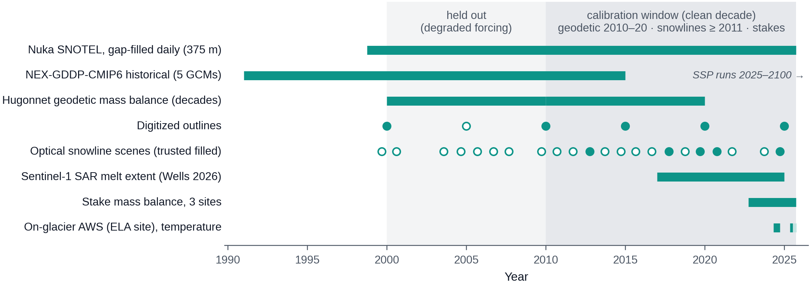
Fig. S1. Period covered by each record used in the study. Bars are continuous records: the gap-filled daily series of the Nuka SNOTEL station, the historical runs of the 5 NEX-GDDP-CMIP6 climate models (Thrasher and others, 2022) (their scenario runs cover 2025–2100, beyond the axis), the two geodetic decades of Hugonnet and others (2021), the Sentinel-1 melt-extent series of Wells and others (2026), the stake mass balances at three sites and the two summers of the on-glacier weather station, whose 2025 temperature record ends on 13 July 2025. Circles are dated observations. Of the digitized outlines, the open circle at 2005 is a duplicate of the 2000 outline and is not used. Of the 22 optical snowline scenes, the 5 filled circles pass the timing filter of Section 3.5 and enter the calibration; open circles do not. Light shading marks 2000–2010, the decade withheld from calibration because its station forcing is degraded. Darker shading marks the calibration window, which holds the 2010–2020 geodetic balance, every trusted snowline and the stakes. Each row is drawn from the loader that supplies the model, so the figure changes if the data package does.
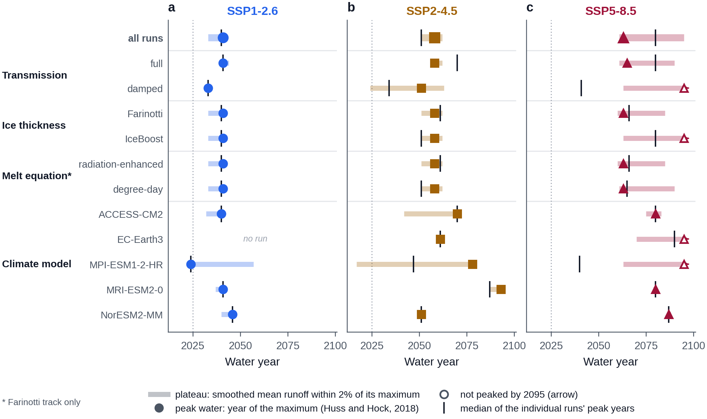
Fig. S2. Effect of each bracket on peak water, by scenario: SSP1-2.6 (a), SSP2-4.5 (b) and SSP5-8.5 (c). Each row is the subset of runs at one level of one uncertainty axis, with the other axes pooled: all runs, the two transmission members, the two ice-thickness tracks, the two melt equations (Farinotti track only) and each GCM; EC-Earth3 has no SSP1-2.6 run. The filled marker is peak water of the subset, the year of the maximum of the 11-year centred mean of its mean runoff (Huss and Hock, 2018). An open marker at 2095 means that the mean curve had not turned over by the last year the window resolves. The pale bar is the plateau, the years in which the smoothed mean is within 2% of its maximum. The black tick is the median of the individual runs’ peak years. The dotted vertical line is 2025. The thickness tracks and the melt equations leave the peak year where it is, or inside the same plateau; the transmission members and the GCMs move it. Where the tick lies decades before the marker, under damped transmission and for MPI-ESM1-2-HR, many runs peak in the observed decade although the mean curve peaks later (Section 5.5).

References
Beven K (2006) A manifesto for the equifinality thesis. Journal of Hydrology 320(1-2), 18–36. doi:10.1016/j.jhydrol.2005.07.007.
Braithwaite RJ (2008) Temperature and precipitation climate at the equilibrium-line altitude of glaciers expressed by the degree-day factor for melting snow. Journal of Glaciology 54(186), 437–444. doi:10.3189/002214308785836968.
Carturan L, Cazorzi F, De Blasi F and Dalla Fontana G (2015) Air temperature variability over three glaciers in the ortles–cevedale (italian alps): Effects of glacier fragmentation, comparison of calculation methods, and impacts on mass balance modeling. The Cryosphere 9(3), 1129–1146. doi:10.5194/tc-9-1129-2015.
Farinotti D and others (2019) A consensus estimate for the ice thickness distribution of all glaciers on earth. Nature Geoscience 12(3), 168–173. doi:10.1038/s41561-019-0300-3.
Foreman-Mackey D, Hogg DW, Lang D and Goodman J (2013) <Tt>emcee</tt> : The MCMC hammer. Publications of the Astronomical Society of the Pacific 125(925), 306–312. doi:10.1086/670067.
Gabbi J, Carenzo M, Pellicciotti F, Bauder A and Funk M (2014) A comparison of empirical and physically based glacier surface melt models for long-term simulations of glacier response. Journal of Glaciology 60(224), 1140–1154. doi:10.3189/2014jog14j011.
Gardner AS and others (2009) Near-surface temperature lapse rates over arctic glaciers and their implications for temperature downscaling. Journal of Climate 22(16), 4281–4298. doi:10.1175/2009jcli2845.1.
Gardner AS and Sharp M (2009) Sensitivity of net mass-balance estimates to near-surface temperature lapse rates when employing the degree-day method to estimate glacier melt. Annals of Glaciology 50(50), 80–86. doi:10.3189/172756409787769663.
Geck J, Hock R, Loso MG, Ostman J and Dial R (2021) Modeling the impacts of climate change on mass balance and discharge of eklutna glacier, alaska, 1985–2019. Journal of Glaciology 67(265), 909–920. doi:10.1017/jog.2021.41.
Hawkins E and Sutton R (2009) The potential to narrow uncertainty in regional climate predictions. Bulletin of the American Meteorological Society 90(8), 1095–1108. doi:10.1175/2009bams2607.1.
Hock R (2003) Temperature index melt modelling in mountain areas. Journal of Hydrology 282(1-4), 104–115. doi:10.1016/s0022-1694(03)00257-9.
Hock R (1999) A distributed temperature-index ice- and snowmelt model including potential direct solar radiation. Journal of Glaciology 45(149), 101–111. doi:10.3189/s0022143000003087.
Hugonnet R and others (2021) Accelerated global glacier mass loss in the early twenty-first century. Nature 592(7856), 726–731. doi:10.1038/s41586-021-03436-z.
Huss M, Jouvet G, Farinotti D and Bauder A (2010) Future high-mountain hydrology: A new parameterization of glacier retreat. Hydrology and Earth System Sciences 14(5), 815–829. doi:10.5194/hess-14-815-2010.
Huss M and Hock R (2018) Global-scale hydrological response to future glacier mass loss. Nature Climate Change 8(2), 135–140. doi:10.1038/s41558-017-0049-x.
Huss M and Hock R (2015) A new model for global glacier change and sea-level rise. Frontiers in Earth Science 3. doi:10.3389/feart.2015.00054.
Larsen CF, Burgess E, Arendt AA, O’Neel S, Johnson AJ and Kienholz C (2015) Surface melt dominates alaska glacier mass balance. Geophysical Research Letters 42(14), 5902–5908. doi:10.1002/2015gl064349.
Maffezzoli N, Rignot E, Barbante C, Petersen T and Vascon S (2025) A gradient-boosted tree framework to model the ice thickness of the world’s glaciers (IceBoost v1.1). Geoscientific Model Development 18(9), 2545–2568. doi:10.5194/gmd-18-2545-2025.
Marshall SJ, Sharp MJ, Burgess DO and Anslow FS (2006) Near‐surface‐temperature lapse rates on the prince of wales icefield, ellesmere island, canada: Implications for regional downscaling of temperature. International Journal of Climatology 27(3), 385–398. doi:10.1002/joc.1396.
Marzeion B and others (2020) Partitioning the uncertainty of ensemble projections of global glacier mass change. Earth’s Future 8(7). doi:10.1029/2019ef001470.
McGrath D and others (2018) Interannual snow accumulation variability on glaciers derived from repeat, spatially extensive ground-penetrating radar surveys. The Cryosphere 12(11), 3617–3633. doi:10.5194/tc-12-3617-2018.
O’Neel S and others (2019) Reanalysis of the US geological survey benchmark glaciers: Long-term insight into climate forcing of glacier mass balance. Journal of Glaciology 65(253), 850–866. doi:10.1017/jog.2019.66.
Paul F and others (2013) On the accuracy of glacier outlines derived from remote-sensing data. Annals of Glaciology 54(63), 171–182. doi:10.3189/2013aog63a296.
Petersen L, Pellicciotti F, Juszak I, Carenzo M and Brock B (2013) Suitability of a constant air temperature lapse rate over an alpine glacier: Testing the greuell and böhm model as an alternative. Annals of Glaciology 54(63), 120–130. doi:10.3189/2013aog63a477.
Rantanen M and others (2022) The arctic has warmed nearly four times faster than the globe since 1979. Communications Earth &amp; Environment 3(1). doi:10.1038/s43247-022-00498-3.
Réveillet M, Vincent C, Six D and Rabatel A (2016) Which empirical model is best suited to simulate glacier mass balances? Journal of Glaciology 63(237), 39–54. doi:10.1017/jog.2016.110.
Rounce DR and others (2023) Global glacier change in the 21st century: Every increase in temperature matters. Science 379(6627), 78–83. doi:10.1126/science.abo1324.
Rounce DR, Hock R and Shean DE (2020) Glacier mass change in high mountain asia through 2100 using the open-source python glacier evolution model (PyGEM). Frontiers in Earth Science 7. doi:10.3389/feart.2019.00331.
Rounce DR, Khurana T, Short MB, Hock R, Shean DE and Brinkerhoff DJ (2020) Quantifying parameter uncertainty in a large-scale glacier evolution model using bayesian inference: Application to high mountain asia. Journal of Glaciology 66(256), 175–187. doi:10.1017/jog.2019.91.
Salzen K von and others (2022) Clean air policies are key for successfully mitigating arctic warming. Communications Earth &amp; Environment 3(1). doi:10.1038/s43247-022-00555-x.
Shea JM and Moore RD (2010) Prediction of spatially distributed regional‐scale fields of air temperature and vapor pressure over mountain glaciers. Journal of Geophysical Research: Atmospheres 115(D23). doi:10.1029/2010jd014351.
Sjursen KH, Dunse T, Tambue A, Schuler TV and Andreassen LM (2023) Bayesian parameter estimation in glacier mass-balance modelling using observations with distinct temporal resolutions and uncertainties. Journal of Glaciology, 1–20. doi:10.1017/jog.2023.62.
Szopa S and others (2021) Short-lived climate forcers. Climate change 2021: The physical science basis. Contribution of working group i to the sixth assessment report of the intergovernmental panel on climate change. Cambridge University Press, 817–922. doi:10.1017/9781009157896.008.
Thrasher B, Wang W, Michaelis A, Melton F, Lee T and Nemani R (2022) NASA global daily downscaled projections, CMIP6. Scientific Data 9(1). doi:10.1038/s41597-022-01393-4.
Wells A, Rounce DR and Fahnestock M (2026) Seasonal progression of melt and snowlines in alaska from SAR reveals impacts of warming. npj Climate and Atmospheric Science 9(1). doi:10.1038/s41612-026-01321-y.
Yang R, Hock R, Kang S, Shangguan D and Guo W (2020) Glacier mass and area changes on the kenai peninsula, alaska, 1986–2016. Journal of Glaciology 66(258), 603–617. doi:10.1017/jog.2020.32.
Zeller L, McGrath D, Sass L, O’Neel S, McNeil C and Baker E (2022) Beyond glacier-wide mass balances: Parsing seasonal elevation change into spatially resolved patterns of accumulation and ablation at wolverine glacier, alaska. Journal of Glaciology 69(273), 87–102. doi:10.1017/jog.2022.46.
Zemp M and others (2019) Global glacier mass changes and their contributions to sea-level rise from 1961 to 2016. Nature 568(7752), 382–386. doi:10.1038/s41586-019-1071-0.

